*CFD simulation of CO2 capture using graphene-oxide/MDEA nanofluid in a packed bed column*

Soleiman Mosleh*, Hadis Khaksar

Polymer Engineering Department

Faculty of Gas and Petroleum, Yasouj University

Gachsaran, Iran

*E-mail address of the corresponding author: Mosleh@yu.ac.ir

**Abstract**

*A three-dimensional (3D) model was proposed for carbon dioxide (CO2) capture from a gas mixture using a packed bed column. Nanofluids of graphene-oxide nanoparticles were used as absorbents. The governing equations were solved using computational fluid dynamics technique (CFD), while the concentration and velocity profiles were determined under different operating conditions. The increases in the capture efficiency for graphene-oxide/MDEA nanofluid with concentration of 0.05 vol% in comparison with bare MDEA was 24.30%. The obtained results from the proposed model were compared with the experimental data, which findings revealed that there was a good agreement between the CFD predictions and the experimental results.*

Keywords: CFD, Nanofluid, CO2 Capture, Packed bed, Graphene-oxide/MDEA

_________________________________________________________________________________________________

1. Introduction

A dramatic demand for energy, especially fossil fuels, has led to the emission of environmental pollutions. This can mainly correspond to a huge amount of CO2 emitted during operational processes in different industries [1]. Despite different international activities such the Kyoto Protocol and the Paris Agreement for CO2 reduction, it seems that no serious actions have been done at the industry level. CO2 is one of the main sources of greenhouse gases which its emission should be controlled owing to associated with rising global mean surface temperature [2]. Although various techniques such as liquid phase absorption, solid-phase adsorption, cryogenic, and membrane separation have been used to capture CO2, each of them has its benefits and limitations. Among the various techniques, the Amine-based absorption process is widely used especially in oil refineries [3]. Despite the acceptable efficiency, absorption using Amin solutions is still an energy-intensive method. Since the CO2 solubility in the liquid phase is a function of temperature and pressure, its solubility increases by increasing pressure and decreasing temperature. Hence, high pressure and low temperature conditions are the desired operating conditions for absorption processes. These operating conditions are energy intensive, which results in high operating costs [4]. The gas-liquid mass transfer plays an important role in the CO2 capture process. Therefore, finding an efficient technique that could improve the mass transfer between gas and liquid leads to reducing the equipment volume and operating costs [5]. The addition of nanostructures to the Amine solutions can be an innovative method to enhance mass transfer. The micro-convection related to the presence of suspended nanostructures can affect the energy transfer process inside the solution [6]. In fact, adding the nanostructures to the solvents to achieve nanofluids can significantly reduce the mass transfer resistance and enhance the absorption process performance [7]. Accordingly, in this work the performance of graphene-oxide/MDEA nanofluid was evaluated for intensification of CO2 capture. Moreover, for a better and deeper understanding of the process, a 3D CFD model was developed to simulate CO2 capture using graphene-oxide/MDEA nanofluid in a packed bed column.

1. Experimental Apparatus and Procedures

The schematic diagram of the packed bed setup is shown in Figure 1. The designed system consists of a column filled with Rasching rings, CO2 and N2 cylinders, gas flow meters, pump, and storage tank. To run the experiments, CO2 and N2 flow rates were adjusted using the flow meters then enter to in a packed bed, while the graphene-oxide nanofluid was pumped from the storage tank. To achieve the steady state condition, the system had to operate for 15 minutes. The gas concentration in the inlet and outlet was determined using a CO2-meter. All the experiments were performed at room temperature and atmospheric pressure.

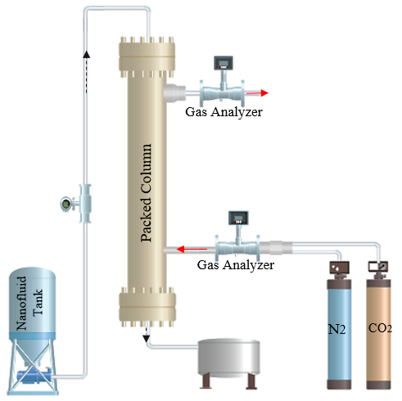

Figure 1. Schematic diagram of used CO2 capture set-up.

1. Model development

A 3D CFD model was employed to predict CO2 concentration profile and depict the hydrodynamics in the packed bed column. The governing equations consist of mass, momentum and energy conservation with other equations such as species transport equations were solved using finite element methods built in the efficient COMSOL Multi-physics software package. The computational domain with different grid sizes was considered and sensitivity analysis was performed to ensure that the CFD predictions are mesh independent and optimal number of cells was used. Finally, the computational domain with 6052 cells is suitable for the modeling purpose. The schematic sketch of the packed bed column geometry is shown in Figure 2.



Figure 2. Schematic sketch of the packed bed column geometry.

1. Results and discussions

Contour plots of velocity magnitude and pressure at the different sections are shown in Figure 3 and Figure 4, respectively, while the contour plot of CO2 concentration during the column length is shown in Figure 5. The Findings indicated that at a given gas flow rate, the capture efficiency increases by increasing the nanofluid volume fraction. The performance of graphene-oxide/MDEA nanofluid for CO2 capturing was higher than bare MDEA solution. The increase in the capture efficiency for graphene-oxide/MDEA nanofluids with containing 0.05 vol% of nanoparticles in comparison with bare MDEA was 24.30%. This higher performance may be owing to the grazing effects, micro-convection, and Brownian motions. According to the grazing effect, the graphene-oxide nanoparticles adsorb the absorbing CO2 molecules in a small film layer, and then move right through the concentration boundary layer, finally desorb the adsorbed molecules into the bulk liquid. Presence of nanoparticles also can cause micro-convection because of the Brownian motion of graphene-oxide nanoparticles, which in turn the micro-convection can improve the mass diffusion in the graphene-oxide/MDEA nanofluid. By contrast, the shuttle mechanism resulting from the movement of the graphene-oxide nanoparticle to and from the liquid–gas interface absorbs the CO2 and desorbs it to bulk the liquid. Hence, the continuous movement of graphene-oxide nanoparticles between the bulk liquid and liquid–gas interface enhances the mass transfer.

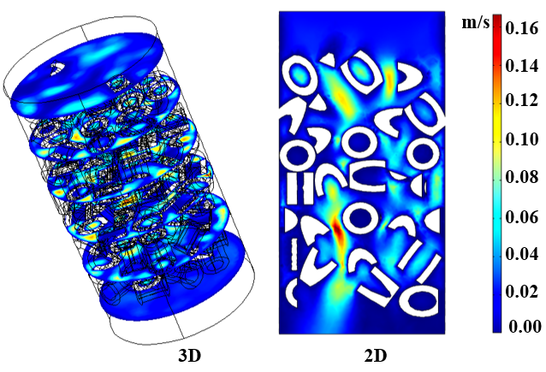

Figure 3. Contour plot of velocity magnitude (Gas phase) at the different sections.

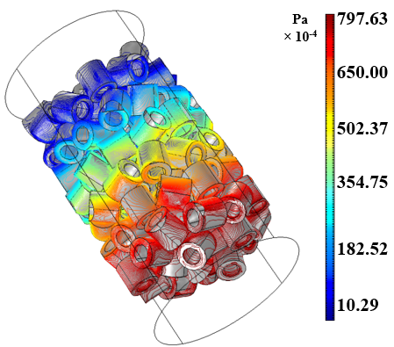

Figure 4. Contour plot of pressure (Gas phase) along the packed bed.

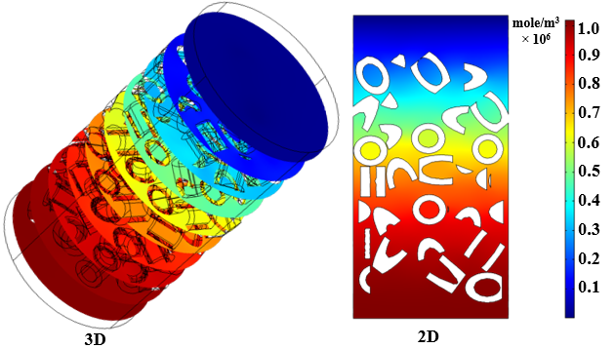

Figure 5. Contour plot of CO2 concentration during the column length.

In order to verify the reliability and exactness of the CFD models, the predicted CO2 capture efficiency was compared with the experimental data. Comparison between the CFD predictions and experimental data (Figure 6) showed a good agreement between the experimental data and CFD results.

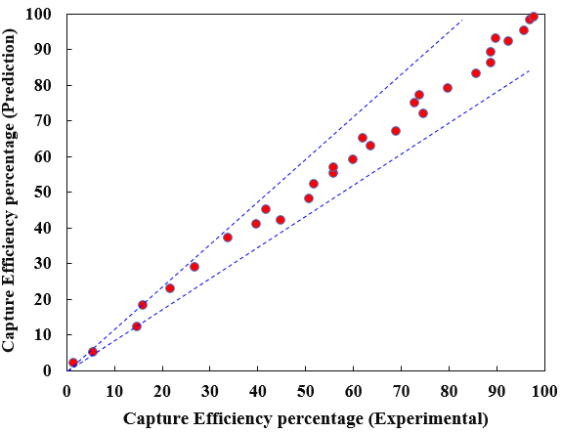

Figure 6. Comparison plot of the experimental and predict data.

1. Conclusion

A comprehensive CFD model was developed to simulate CO2 capture using graphene-oxide/MDEA nanofluid in a packed bed column. The system operated in a countercurrent mode. For the model development, momentum and mass transfer equations were considered and were solved simultaneously. The model validation was evaluated through comparing the results obtained with the available experimental data. Findings indicated that the simulated results were in very good agreement with experimental data.

References

[1] Lee, W., Xu, R., Kim, S., Park, J.H. and Kang, Y.T., 2021. Nanofluid and nanoemulsion absorbents for the enhancement of CO2 absorption performance, Journal of Cleaner Production, 291, 125848.

[2] Ghasemi, M.H., Irani, V. and Tavasoli, A., 2020. Amino functionalized ZIF-90@ GO/MDEA nanofluid: As a new class of multi-hybrid systems to enhance the performance of amine solutions in CO2 absorption. Journal of Natural Gas Science and Engineering, 74, 103110.

[3] Elhambakhsh, A. and Keshavarz, P., 2020. Effects of different amin-based core-shell magnetic NPs on CO2 capture using NMP solution at high pressures, Journal of Natural Gas Science and Engineering, 84, 103645.

[4] Pahlevaninezhad, M., Etesami, N. and Nasr Esfahany, M., 2021. Improvement of CO2 absorption by Fe3O4/water nanofluid falling liquid film in presence of the magnetic field, The Canadian Journal of Chemical Engineering, 99, 519-529.

[5] Cheng, S.Y., Liu, Y.Z. and Qi, G.S., 2020. Experimental study of CO2 capture enhanced by coal fly ash-synthesized NH2-MCM-41 coupled with high gravity technology, Chemical Engineering Journal, 400, 125946.

[6] Rahimi, K., Riahi, S. and Abbasi, M., 2020. Effect of host fluid and hydrophilicity of multi-walled carbon nanotubes on stability and CO2 absorption of amine-based and water-based nanofluids. Journal of Environmental Chemical Engineering, 8, 103580.

[7] Salih, H.A., Pokhrel, J., Reinalda, D., AlNashf, I., Khaleel, M., Vega, L.F., Karanikolos, G.N. and Zahra, M.A., 2021. Hybrid–Slurry/Nanofluid systems as alternative to conventional chemical absorption for carbon dioxide capture: A review, International Journal of Greenhouse Gas Control, 110, 103415.