*Flow characteristic modeling in coiled flow inverters and helically coiled channels by CFD*

Reza Beigzadeh*

Department of Chemical Engineering

University of Kurdistan

Sanandaj, Iran

Mahtab Izadi, Masoud Rahimi

Chemical Engineering Department

Razi University

Kermanshah, Iran

* r.beigzadeh@uok.ac.ir

**Abstract**

*The flow characteristic is an important factor for many systems, like fine chemicals, pharmaceuticals, and crystallization. In this study, a 3D Computational Fluid Dynamics (CFD) model was done for analyzing flow characteristics in three coiled flow inverters and a helically coiled channel. The laminar Finite-Rate model was used to develop the model. The effects of Reynolds number (Re) and geometries on the flow characteristic were studied. The friction factor of various shapes was evaluated using the CFD model. The major objective of this study is to demonstrate the effects of geometry on pressure drop and friction factor as a flow characteristic from the fluid dynamics point of view. Results show that the coiled flow inverters have an important influence on mixing performance at various Reynolds numbers.* *The results show* *that the friction factor increased as the number of 90˚ bends increased. In addition, the friction factor of the coiled flow inverters is significantly higher than the helically coiled channel.*

Keywords- flow characteristic; coiled flow inverters; helically coiled channel; CFD.

_________________________________________________________________________________________________

1. Introduction

Helical tubes were commonly used as heat exchangers and static mixers due to the impressive mixing of the flow in the laminar flow regime, the admissible pressure drop, and further heat and mass transfer [1-3]. Kumari et al. [4] assessed the mixing characteristics of two innovative types of coil flow inverters, asymmetric coil flow inverter (SCCFI) and asymmetric coil flow inverter (ACCFI) to standard coil flow inverter (CFI), through numerical analysis under the state of laminar flow without diffusion. The CFD results showed that the Dean vortices and flow inversion are intensified by the Dean number, which explains the narrowing effect as the Dean number increases. Gaddem et al. [5] developed a new CFD modeling method to investigate the hydrodynamics and mass transfer in a gas-liquid slug flowing through microscale coil and coiled flow inverter channels. The new model well explained the temporal and spatial distribution of species in the slug. The volumetric mass transfer coefficient was found to be 1.5 times higher in the coiled than in the straight channel. For the helical pipes, Mansour et al. [6] studied multi-objective optimization for mixing liquid-liquid systems with genetic algorithm and CFD. The variables used in the optimization method as input were tube diameter, coil pitch, coil diameter, and Re. The results showed how to achieve highly efficient mixing with minimal cost. For a liquid-liquid or liquid-air inverter system, Kumar et al. [7] described the coiled flow inverter in the form of a heat exchanger on the size of a pilot. The effect of flow rate on hydrodynamics and heat transfer was also studied in the tube on the heat exchanger shell side. Sony et al. [8] focused on flow intensity and mixing in coiled flow inverter (CFI) geometries to achieve higher mixing efficiency with less base footprint. This study showed that the symmetrical compact coiled flow inverter has the highest mixing efficiency per unit area, and requires the minimum length of coil tube to reduce the axial dispersion by the same amount. Therefore, symmetric CFI has significant potential savings in energy costs of materials and operations in the industry. Kougoulos et al. [9] investigated a novel predictive compartmental modeling framework for the dynamic simulation and scale-up of batch cooling suspension crystallization vessels within gPROMS process modeling software based on CFD simulations. A detailed compartmental model is constructed for batch crystallizers equipped with two different impeller configurations based on the overall flow pattern, local energy dissipation, solids concentration, and temperature distribution from CFD simulations. In another study, Naher et al. [10] studied the effect of microchannel geometry on fluid flow characteristics and mixing efficiency without reaction and showed that the mixing performance strongly depends on channel geometry. In this study, the friction factors in three coiled flow inverters with different geometries and a helically coiled channel were investigated and compared using the CFD model.

1. CFD modeling study

The studied geometries have been shown in Figure 1. Figure 1(a) shows a helically coiled tube and figure 1(b) shows coiled flow inverters (CFIs) with the various number of 90˚ bends. The inner diameter and the coil diameter of all geometries are 3 and 30 mm, respectively. The length of the investigated helical coiled tube was 0.567 m and the length of 1.45, 3.89, and 7.85 m were selected for CFIs. The water was injected at different flow rates in all geometries. The fluid properties used for the simulations were listed in Table 1.

a)

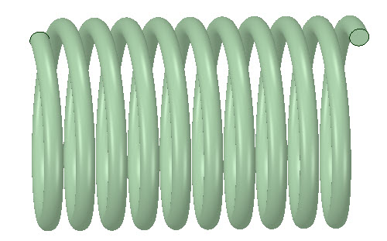

3 mm

30 mm

b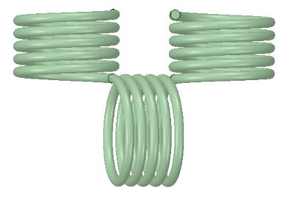)

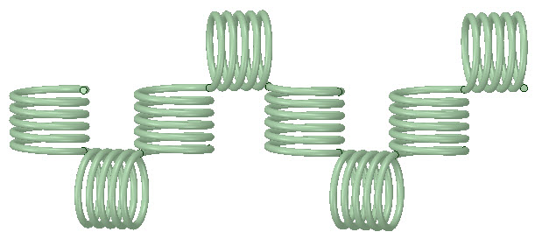

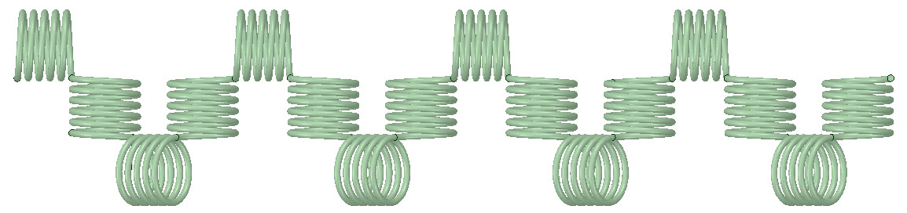

Figure 1. The studied geometries of a) helically coiled tube (HCT) and b) coiled flow inverters (CFIs).

Table 1. the water properties used for fluent simulations.

|  |  |
| --- | --- |
| Property | Value |
| Density (kg/m) | 998.2 |
| Cp (J/kg k) | 4182 |
| Thermal conductivity (W/m k) | 0.6 |
| Viscosity (kg/m s) | 0.001 |
| Molecular weight (kg/kg mol) | 18.0512 |
| Standard state entropy (J/kg mol) | 69902.2 |
| Reference temperature (K) | 298 |
| Vaporising temperature (K) | 284 |
| Boiling point (K) | 373 |
| Saturation vapour pressure (Pa) | 2658 |

In the present work, the 3D CFD modeling was done to obtain the flow characteristics. The objective of the simulation is to achieve a better understanding of the influence of geometry and the flow rate on the flow pattern and mixing efficiency in the tubes. The CFD simulation includes numerical solutions of the steady equations for mass, momentum, and energy based on a finite volume technique [11].

The meshed geometries were shown in Figure 2. In order to make sure that the solution is independent of mesh sizes; different mesh schemes with different grid sizes were applied and the pressure drop in the channels was calculated. There was no important change in the obtained pressure drop for larger than 159324 cells, so this layout was used to reduce the time of calculations.

a)

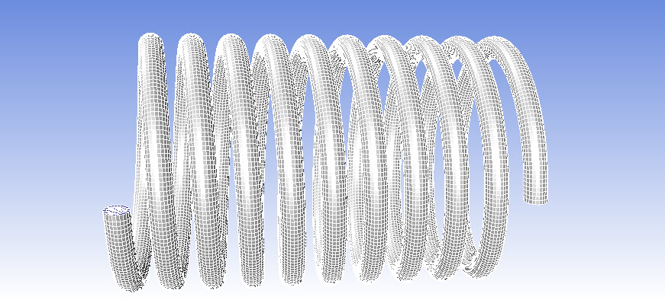

b)

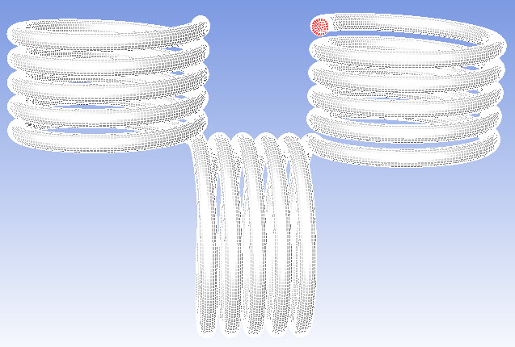

Figure 2. The meshed geometries of (a) helically coiled channel and (b) coiled flow inverter with 2 bends.

The constant velocity inlet boundary condition with the wall no-slip assumption was used and atmospheric pressure was employed at the outlet surface. The laminar range flow regime with the Reynolds numbers between 100 and 300 was considered in the modeling. The steady-state condition was utilized in the modeling. The SIMPLE procedure was employed for coupling between pressure and velocity. To achieve higher numerical precision, the discretization scheme of upwind second-order was used for the momentum. The outcome results were finalized as soon as the residual values were lower than 10-7 for the momentum and continuity equations. All geometrical parameters have been selected in a suitable range as shown in Table 2.

Table 2. Ranges of used parameters in the simulation.

|  |  |
| --- | --- |
| Parameter | Range |
| Length (L, m) | 1.45 – 7.85 |
| No. of 90˚ bend | 2,7,15 |
| Reynolds number (Re) | 100 – 300 |

From CFD modeling results, the pressure drop for four geometries was calculated at different Reynolds numbers (100-300). The friction factor has been used to investigate the flow characteristic. The coiled flow inverters and helically coiled channels have different lengths from 1.45 to 7.85 m. The friction factor was used to determine the flow characteristic due to independence from the length of the pipes

The calculation of the friction factor (f) was based on the fanning equation as follow:

f = (2 $∆Pd)/(ρv^{2}L)$ (1)

where L is the coiled flow inverters length, d is the tube diameter, ρ is the density, and v is the fluid velocity.

1. Results and discussions

In this study, four various layouts with different numbers of 90˚ bend (as shown in Figure 1) were modeled. The friction factors were calculated according to equation (1) at several Reynolds numbers. The obtained results are shown in Figure 3. In the figure, the friction factor values for the various geometries were plotted in terms of the Reynolds number. Figure 3 shows that the friction factor decreased with increasing Reynolds number. The friction factor in coiled flow inverters is higher than the helically coiled tube due to the 90˚ bend in coiled flow inverters that leads to a more pressure drop. In addition, as shown in the figure, the friction factor increased as the number of 90˚ bends increased.

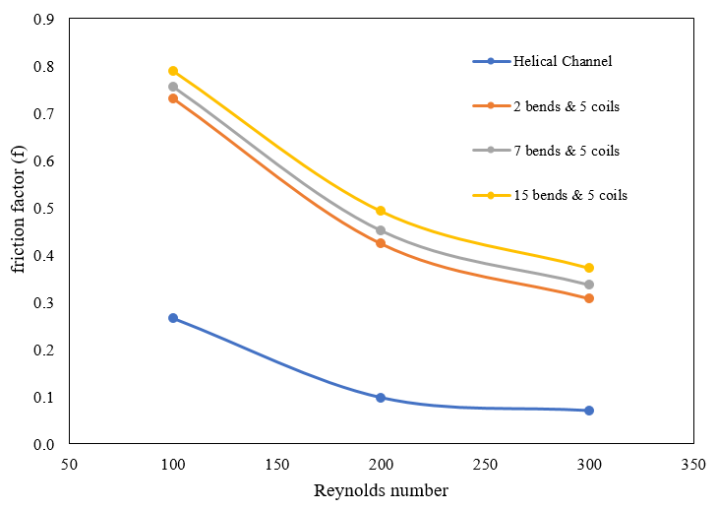

Figure 3. Friction factor values for the investigated geometries.

In this work, the ratio of the obtained friction factor in the coiled flow inverters (*f*) to the helically coiled tubes (*fh*) was investigated at different Re. As shown in Figure 4, all ratios are greater than one, and as the Reynolds number increases, this ratio increases. The rate of *f/fh*change from Re=100 to Re=200 is more than Re=200 to 300, therefore, the increase of *f/fh* between Reynolds number of 100 and 200 is more obvious. Figure 4 shows as the number of 90˚ bend increases, the ratio of f and fh increases.

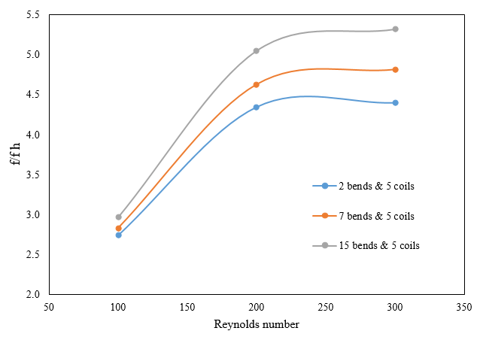

Figure 4. The ratio of the friction factor in the coiled flow inverters to helically coiled tubes

The pressure contour of the coiled flow inverter and the helically coiled tube was illustrated in Figure 5. Due to the presence of centrifugal force, flow separation occurs and the separation and reconnection of the fluid in 90˚ bends leads to the creation of secondary flows and Dean vortices.

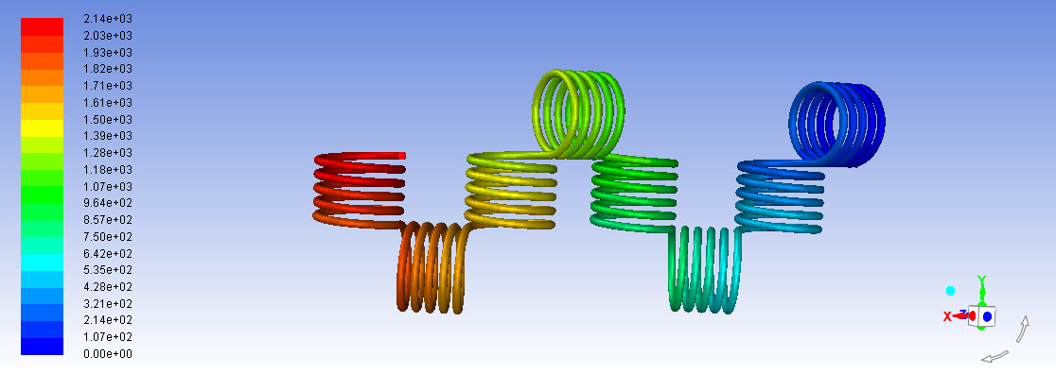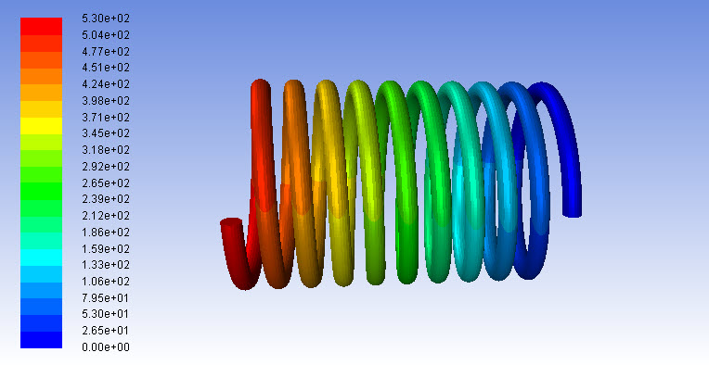

Figure 5. The pressure contour of the coiled flow inverter and helical coiled tube.

1. Conclusion

In this study, a 3D computational fluid dynamics model was done for analyzing flow characteristics in three coiled flow inverters (CFIs) and helically coiled channel (HCC). CFD models were successfully developed for four different geometries. It was observed that the friction factor decreased with increasing Reynolds number. The reason for this behavior can be attributed to the flow characteristics near the curved areas. Due to the presence of centrifugal force, flow separation occurs and this separation and reconnection of the fluid in these areas leads to the creation of secondary flow and vortices of religion. The ratio of friction factor in CFIs and HCC in terms of Reynolds number was calculated. It was concluded that by increasing the Reynolds number, the ratio *f*/*fh* increased. The ratio of *f* and *fh* increased when the number of 90˚ bends increased.

1. References
2. Vashisth S., Kumar V., & Nigam K. D, 2008. A review on the potential applications of curved geometries in process industry. Industrial & Engineering Chemistry Research, 47(10), 3291-3337.
3. Kumar V., Saini S., Sharma M., & Nigam K. D. P, 2006. Pressure drops and heat transfer study in tube-in-tube helical heat exchanger. Chemical Engineering Science, 61(13), 4403-4416.
4. Mandal M., Serra C., Hoarau Y., & Nigam K, 2011. Numerical Modeling of Polystyrene Synthesis in Coiled Flow Inverter Microfluid.
5. Jha V. K., Sharma L., Roy S., Nigam K. D. P., & Bhaumik S. K., 2020. Comparative assessment of mixing in compact coiled flow inverters under diffusion free laminar flow condition. Chemical Engineering Research and Design, 159, 455-467.
6. Gaddem M. R., Ookawara S., Nigam K. D., Yoshikawa, S., & Matsumoto H, 2021. Numerical modeling of segmented flow in coiled flow inverter: Hydrodynamics and mass transfer studies. Chemical Engineering Science, 234, 116400.
7. Mansour M., Zähringer K., Nigam K. D., Thevenin D., & Janiga G, 2020. Multi-objective optimization of liquid-liquid mixing in helical pipes using Genetic Algorithms coupled with Computational Fluid Dynamics. Chemical Engineering Journal, 391, 123570.
8. Kumar V., Mridha M., Gupta A. K., & Nigam K. D. P, 2007. Coiled flow inverter as a heat exchanger. Chemical Engineering Science, 62(9), 2386-2396.
9. Soni S., Sharma L., Meena P., Roy S., & Nigam K. D. P, 2019. Compact coiled flow inverter for process intensification. Chemical Engineering Science, 193, 312-324.
10. Kougoulos E., Jones A. G., & Wood-Kaczmar M, 2005. CFD modelling of mixing and heat transfer in batch cooling crystallizers: Aiding the development of a hybrid predictive compartmental model. Chemical Engineering Research and Design, 83(1), 30-39.
11. Naher S., Orpen D., Brabazon D., Poulsen C. R., & Morshed M. M, 2011. Effect of micro-channel geometry on fluid flow and mixing. Simulation Modelling Practice and Theory, 19(4), 1088-1095.
12. Versteeg H. K., & Malalasekera W, 2007. An introduction to computational fluid dynamics: the finite volume method. Pearson education.