**Centrifugal Pump Performance Analysis Affected by changes in the Blade Wrap Angle of impeller**

**Ebrahim Ebrahimi1*, Ali abdulhussien kareem1, Faezeh Mohammadi2**

1Departement of Mechanical Engineering, Faculty of Enginering,Kermanshsh Branch, Islamic Azad University

2 Departement of Chemical Engineering, Faculty of Enginering,Kermanshsh Branch, Islamic Azad University

## 

# **Abstract**

Centrifugal pumps are widely used in industrial and agricultural fields (irrigation and water supply). The impeller is the main part of a pump And converts mechanical energy into hydraulic pressure. The impeller directly determines the fluid displacement capacity and hydraulic performances of the pump. Accordingly, the optimal design of the impeller is necessary and significant for have the efficient operation of the centrifugal pump thus the main purpose of this study is to investigate the changes in the wrap angle in the centrifugal pump impeller blade on pump performance. In this study, the centrifugal Ets-Norm centrifugal pump (model 2.50 / 100, manufactured by Pumpiran Company) was investigated and analyzed. The impeller installed on the pump shaft was closed with 5 blades and a radius of 170 mm, the blade thickness was 6 mm and the impeller outlet angle was 20 degrees. The effect of the blade wrap angle was studied on the pump performance. The five impellers were designed with wrap angles (100 °, 105 °, 110 °, 115 ° and 120 °). The effects of changing the wrap angle on the head, flow, efficiency and pressure distribution on the pump impeller were analyzed. The results showed that with increasing the wrap angle of the impeller blade, the amount of head and pump flow decreased and also, with increasing the wrap angle, the amount of pump efficiency decreased so that with increasing the warp angle from 100 degrees to 120 degrees, the amount of pump efficiency decreased by 4.93%. The results showed that with increasing the impeller wrap angle, the pressure on the blade at the fluid inlet to the impeller increased and the area under high pressure at the impeller inlet was larger than the outlet impeller.

**Keywords**: Centrifugal Pump, CFTurbo, impeller geometry.

## **Introduction**

The centrifugal pump is of wide application in industrial and agricultural productions, consuming a large amount of electric power with great potential in energy saving. Among all components in the centrifugal pump, the impeller is the most important flow passage because it is the only part that does work [2]. Generally, there are two ways to optimize the performance of centrifugal pump. One is to study the effect of a single parameter or structure on the performance of centrifugal pump. Skrzypacz and Bieganowski [3] studied the influence of micro grooves on centrifugal pump performance by numerical simulation and experiment. The results illustrated that micro-blades can make the velocity distribution in the impeller passage more uniform, which thus improves the head and efficiency of the pump. Chen et al., [4] put forward the concept of wraped vice blade, and verified that the use of wraped vice blades can effectively improve the comprehensive performance of centrifugal pumps. Nishi et al., [5] found the influence of blade outlet angle on radial thrust and modeled components is obvious by experiments and CFD analysis. Fu et al., [6] uncovered how the diffuser vane height affects the pump performance. They concluded that reducing the diffuser vane height could improve the output work of impeller. Cui et al., [7] found that a larger blade outlet angle could improve the internal flow of low-specific-speed centrifugal pump and improve its working efficiency. The other common optimization method is to use some mathematical models or algorithms to study the comprehensive effects of several parameters on the performance of centrifugal pumps, such as DOE (Design of Experiments) [8], approximation models, genetic algorithm, etc.[9]. Wang et al., [10] selected blade inlet angle, outlet angle, and blade wrap angle as the optimization variables. The multi-objective optimization was carried out based on NSGA-II genetic algorithm. The optimization results show that the algorithm can effectively improve the performance of centrifugal slurry pump. Derakhshan et al., [11] adopted the ABC (artificial bee colony) and ANNs (artificial neural networks) algorithm to design a new flow passage shape of centrifugal pump. Zhang et al., [12] used Kriging metamodels to optimize double suction centrifugal pump based on four different parameters. Lomakin et al., [13] chose six parameters of impeller and guide vane as optimization parameters, and used LP-tau algorithm to optimize the centrifugal pump to improve its comprehensive performance, including increasing head, reducing cavitation, and vibration phenomenon. Koor et al., [14] used the LMA (LevenbergMarquardt algorithm) to maximize the total efficiency of the pump system and thereby minimize energy consumption. Centrifugal pump has wide channel and the blade wrap angle size will directly affect its hydraulic performance. The blade wrap angle represents the diffusion degree of blade passage. Figure 1 shows the schematic diagram of blade wrap angle; it is defined as the included angle of two lines, one is the connecting line of the blade inlet edge and the centre, another is the connecting line of blade outlet edge and the center[15]. The blade wrap angle is defined as the one between the tangent lines at leading and trailing edges of the blade. An increase in blade wrap angle would lead to a longer flow passage between the blades and thus a significant rise in friction loss. On the contrary, a small blade angle will generate a short flow passage but result in a poor control on the flow in impeller arousing separation loss probably. Therefore, the blade wrap angle is a key parameter for blade shape, flow pattern in impeller and performance of pump [16]. Both numerical and experimental results verify the design method and numerical analysis, and demonstrate that the blade wrap angle is a very important parameter in pump designing and has a great influence on pump performance [17]. Therefore, in this study, the effect of different blade warp angle on the performance of a pump model was investigated.

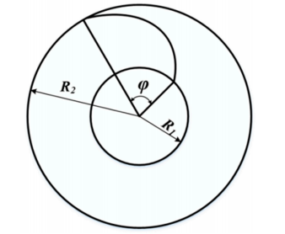

Figure 1-Schematic diagram of blade wrap angle [1].

# **2.Pump Modeling Methods**

## **Pump components**

Centrifugal pumps are one of the most common types of radial flow turbomachines. These pumps are made up of two major components. The first component is known as the impeller, and it is connected to a rotating shaft. The second component is known as the casing or volute, and it encloses the impeller. In a centrifugal pump, the fluid first enters the impeller, increasing its acceleration, before exiting the impeller radially and entering the diffuser or volute. Figure 2 shows the main components of a centrifugal pump. In this study, the design goal was focused on the pump impeller. Figure 2 shows the main components of a centrifugal pump impeller. All of the parameters depicted in Figure 2 have an impact on the pump's performance and characteristic curves. As previously stated, the purpose of this study was to examine the effect of changes in pump angle of wrap on the performance of a centrifugal pump.

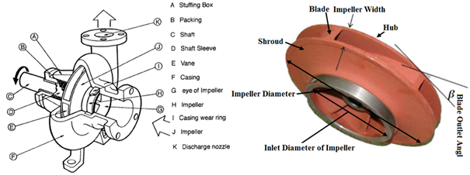

Figure 2-The main components of a centrifugal pump (Left) and impeller (Right)

## **Characteristics of prototype pump**

Steel industry is one of the essential industries for the development of any community, the mother industry of any country that needs a large amount of water to carry out production and processing processes. In this regard, the pump that was selected for review and analysis was one of the most widely used pumps in Jahan Foolad Company. The pump is made by Pumpiran Company, which has a maximum head of 60 m and a maximum discharge of 100 m3/h at a rotational speed of 1450 rpm. The pump model is centrifugal etanorm, 2.50-100. The studied pump can be used in the flowrate range of 40 to 180 liters per minute (l/min) and the head of 55 to 90 meters. This pump is one of the medium size pumps and needs a power equivalent to 5.5 Kw. The pump is used in a water cooling system. The water density was considered 998 kg / m3. The operating temperature of the pump is the same as the ambient temperature and the temperature of fluid is approximately equal to 20 oC. The pump has an enclosed impeller type with five blades and a radius of 170 mm. The thickness of the blades was 6 mm and it was fixed along the entire length of the blades. In fact, the impeller cross-section was fixed and the impeller exit angle was 20 degrees.

## **Research Variables**

The effect of 5 levels of pump angle of wrap on the performance of a centrifugal pump was investigated in this study. The values considered for the impeller blade angle of wrap include 100, 105, 110, 115, 120 degrees. This study examined the head-discharge curve, efficiency-dischargeand pressure distribution.

## **Pump and Impeller Design**

The centrifugal pump impeller was designed and modeled using CFTurbo. CFturbo is intended for the design of radial, mixed, and axial flow turbomachines in a wide range of pumps, ventilators, compressors, and turbines. The information of the pump design point must be entered in the Global Setup (Fig. 3). The type of impeller is specified in the **Setup** section in terms of whether it is shrouded or not. The shroudless impeller must be used in semi-open impellers. The designer can then enable the "Splitter Blades" option if he or she intends to use middle and small blades between the main blades in addition to the main blades. The three main parameters for the pump must be specified in the next menu, "**Parameters**." These three parameters include Intake Number, Work Coefficient, and Outlet Width Ratio. All three of these parameters depend on the specific speed value.

### **Pump impeller design**

The impeller meridian view, which includes the hub view, the shroud view, and the blade view, is designed first in this section. The Basic drawing system must be selected when selecting the design parameters for all three parts of the impeller so that the desired geometric shape can be easily designed. Figure 3 shows the pump impeller meridional design environment. The changes in the impeller cross-section along the width of the hub are shown to the right of Figure 3. The impeller model should be designed in such a way that the slope of this diagram is as consistent as possible. Following that, the design of the pump impeller, blade eccentric angle, blade wrap angle, number of blades, blade thickness, shape of blade contact with fluid, and other variables that are determined by the model of these variables can be changed and designed. The process of designing the impeller is completed once the above parameters are designed based on the required model.

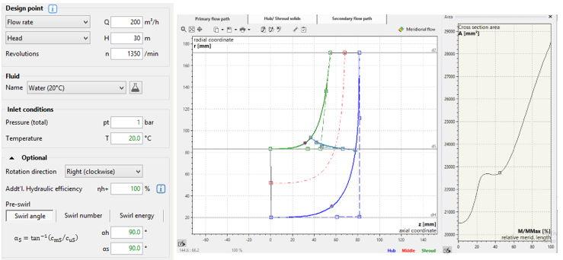

Figure 3-Left: Global Setup window at the beginning of the problem definition. Rght: Pump impeller meridional design

environment

### **Voulte design**

The initial settings in this section are set to adjust the position of the voulte in relation to the impeller, the width of the voulte, the distance of the voulte from the impeller, and the transverse position of the impeller in relation to the voulte. The cross-sectional shape of the voulte can then be selected. The cross-section of a voulte can be rectangular, circular, elliptical, or any other shape.

### **Diffuser and cut water design**

The diffuser design and its design parameters are shown in Figure 4 (Left). Three methods for connecting the diffuser to the voulte are shown in the diffuser design in the square section. The option to connect the diffuser to the voulte can be determined in the red square. Another parameter to consider when designing a diffuser is the diffuser's height. If the height is high, a lot of force is applied to the pump and the installation site, and if it is low, the diffuser opening becomes divergent, which is not a good design. The cut water area refers to the area where the impeller delivers fluid from the voulte to the diffuser. Figure 4 (Right) shows the cut water position. Cut water design should be done so that the internal leakage in the pump is not excessive and that its distance from the impeller is not so great that the impeller collides with it.

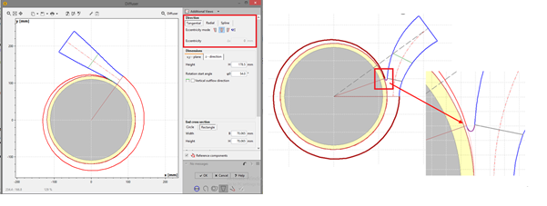

Figure 4-Left:Diffuser design and determining design parameters. Right: Cutwater design window

# **Result and Discussion**

Figure 5 shows the simulated impeller in the CFTurbo software qnd cross-section of the impeller and the impeller blade position. The five impellers were designed with the blade wrap angle of 100°, 105°, 110°, 115° and 120°. The rest of the geometric parameters remain unchanged. Figure 6 shows the designed impellers. The effects of different wrap angles on the head, discharge, efficiency, and pressure distribution around the pump impeller, were analyzed.

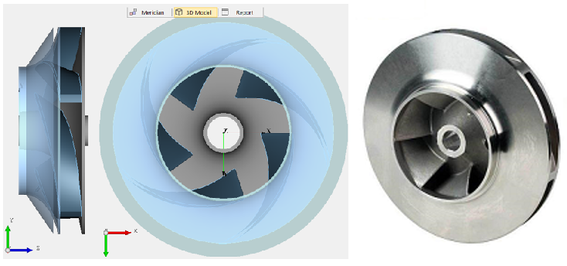

Figure 5-The designed impeller of the centrifugal pump

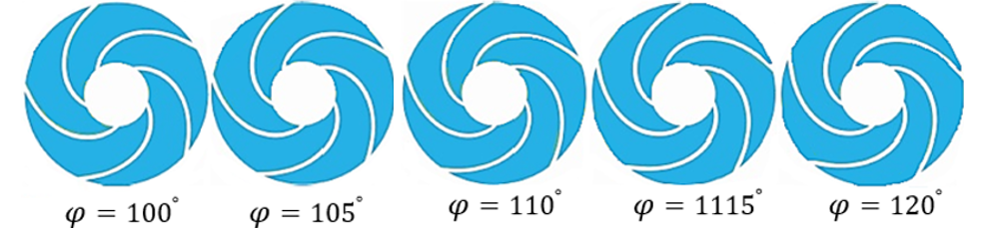

Figure 6-Different models designed for blade wrap angle

## **Effects of different wrap angles on pump performance**

This section presents the influence of wrap angle changes on head-discharge curve and discharge-efficiency curve. Also, the effects of wrap angle on pressure distribution around the pump impeller were investigated.

### **Head-Discharge curve**

Figure 7 shows the head-discharge curve for the different blade wrap angles of the impeller. As the discharge increased, the pump head decreased for all values of the wrap angle. While in constant discharge, the pump head has the maximum value for the minimum value of the blade wrap angle. Also, Figure 7 shows that the pump head decreases when the blade wrap angle increases, whereas the pump discharge decreases with increasing wrap angle. The results show the blade wrap angle has a significant effect on the specification and performance of the pump. For large values of wrap angle, the hydraulic head and efficiency will be reduced.

### **Discharge-Efficiency curve**

Figure 7 shows the effect of blade wrap angle value on the discharge-efficiency curve of the pump. The efficiency first increases with increasing discharge, then decreases. The efficiency-discharge results show the value of pump efficiency decreases with increasing wrap angle. In all different modes of wrap angle, the discharge of 100 m3/ h shows the maximum efficiency, which is the value of working discharge of the pump. Whereas the wrap angle increases from 100 to 120 degrees, the pump efficiency decreases by 4.93%.

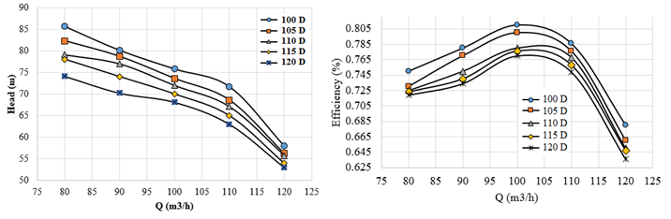

Figure 7-Head-discharge and Efficiency -discharge curve of the pump for different blade wrap angles

### **Distribution of pressure on the pump impeller**

Figure 8 shows the pressure distribution on the centrifugal pump impeller for different values of blade wrap angles. The results show the greater the impeller wrap angle the greater the pressure on the blade at the impeller inlet. Also, larger exit angles has greater area with high pressure at the impeller inlet. However, changing the blade wrap angle does not affect the pressure on the blade outlet edge significantly, so the pressure distribution at the blade outlet is almost the same for all the different values of blade wrap angles.

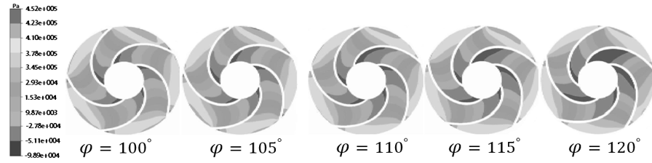

Figure 8: Pressure distribution around the centrifugal pump impeller outlet for different blade wrap angles.

# **Conclusion**

In the present study, five impellers with blade wrap angles of 100o, 105o, 110o, 115o and 120o were designed and other geometric parameters of the impeller remained unchanged. The effects of different blade wrap angles on the performance specifications of the centrifugal pump were investigated. As the discharge increased, the pump head decreased for all of the blade wrap angle values. In constant value of the pump head, the pump discharge decreases with increasing blade wrap angle. As the discharge increases, the efficiency of the pump increases and then decreases. As the impeller wrap angle increases, the pressure on the blade at the impeller inlet increases, and the high-pressure area at the impeller inlet increases for larger values of outlet angle. Finally results showed the blade wrap angle had a significant effect on the specification and performance of the pump, so that by increasing the wrap angle, the head, discharge and pump efficiency decreases.

## **References**

1. Djerroud, M., G. Dituba Ngoma, and W. Ghie, Numerical identification of key design parameters enhancing the centrifugal pump performance: impeller, impeller-volute, and impeller-diffuser. International Scholarly Research Notices, 2011. **2011**.
2. Yang, W., Y. Wu, and S. Liu, An optimization method on runner blades in bulb turbine based on CFD analysis. Science China Technological Sciences, 2011. **54**(2): p. 338-344.
3. Skrzypacz, J. and M. Bieganowski, The influence of micro grooves on the parameters of the centrifugal pump impeller. International Journal of Mechanical Sciences, 2018. **144**: p. 827-835.
4. Chen, H.-x., J.-w. He, and C. Liu, Design and experiment of the centrifugal pump impellers with wraped inlet vice blades. Journal of Hydrodynamics, Ser. B, 2017. **29**(6): p. 1085-1088.
5. Nishi, Y., J. Fukutomi, and R. Fujiwara. Effect of blade outlet angle on radial thrust of single-blade centrifugal pump. in IOP conference series: earth and environmental science. 2012. IOP Publishing.
6. Fu, L., et al., Numerical investigation on influence of diffuser vane height of centrifugal pump. International Communications in Heat and Mass Transfer, 2017. **82**: p. 114-124.
7. Cui, B., et al., Influence of blade outlet angle on performance of low-specific-speed centrifugal pump. Journal of Thermal Science, 2013. **22**(2): p. 117-122.
8. Zhou, L., Z.-x. Wang, and Z.-w. Liu, Investigation on influence of design parameters for tandem cascades diffuser using DOE method. Engineering applications of computational fluid mechanics, 2014. **8**(2): p. 240-251.
9. Lyu, Q., et al., Implementation of design of experiment for structural optimization of annular jet pumps. Journal of Mechanical Science and Technology, 2016. **30**(2): p. 585-592.
10. Wang, C., et al., Multi-objective parameter optimi-zation of slurry pump based on RBF neural network and NSGA-II algorithm. Trans.-Ns Chin. Soc. Agric. Eng, 2017. **33**: p. 109–155.
11. Derakhshan, S., et al., Numerical shape optimization of a centrifugal pump impeller using artificial bee colony algorithm. Computers & Fluids, 2013. **81**: p. 145-151.
12. Zhang, Y., et al., Multi-objective optimization of double suction centrifugal pump using Kriging metamodels. Advances in Engineering Software, 2014. **74**: p. 16-26.
13. Lomakin, V., P. Chaburko, and M. Kuleshova, Multi-criteria optimization of the flow of a centrifugal pump on energy and vibroacoustic characteristics. Procedia Engineering, 2017. **176**: p. 476-482.
14. Koor, M., A. Vassiljev, and T. Koppel, Optimization of pump efficiencies with different pumps characteristics working in parallel mode. Advances in Engineering Software, 2016. **101**: p. 69-76.
15. Tan, M., et al., Effect of Blade Wrap Angle on Performance of a Single-Channel Pump. Experimental Techniques, 2018. **42**(5): p. 481-490.
16. Tan, L., et al., Influence of blade wrap angle on centrifugal pump performance by numerical and experimental study. Chinese journal of mechanical engineering, 2014. **27**(1): p. 171-177.
17. Zhang, X., et al., Relationship between wrap angle of impeller and performance of pump. Transactions of the Chinese Society for Agricultural Machinery, 2010. **41**(11): p. 38-42