Effect of operating and geometric parameters on microwave heating of fluid in continuous mode
Ahmad Alimoradi¹, Jamshid Behin^{*1,2}
¹Faculty of Petroleum and Chemical Engineering, Razi University, Kermanshah, Iran
²Artificial Intelligence Division, Advanced Chemical Engineering Research Center, Razi University, Kermanshah, Iran
Behin@razi.ac.ir

Abstract
The effect of diameter of helical tube and liquid permittivity was investigated on the performance of continuous microwave heating by coupling electromagnetic equations, heat transfer and laminar flow in COMSOL Multiphysics software. The model was implemented numerically using the finite element method and validated with experimental data obtained from a kitchen microwave oven. The results for water as handling fluid show that electromagnetic energy and temperature distribution are sensitive to tube diameter and input power. As the input power and the loss factor of aqueous phase increase, more electromagnetic energy is converted to heat to reduce the electrical intensity and this lead to more temperature differences and efficiency. Moreover, considering a constant residence time of liquid in MW oven, the optimum diameter of helical tube is obtained 6 and 4 mm for to the highest energy conversion efficiency and the highest outlet temperature, respectively.

Keywords: microwave heating; continuous mode, fluid permittivity; tube diameter, thermal field.
____________________________________________________________________________________________________

1. Introduction
Microwave (MW) is an electromagnetic radiation with frequencies ranging from 300 MHz to 300 GHz, which has been broadly used in industrial, scientific, medical and instrumentations applications. As a promising heating method, it has been applied in chemical processes extensively in recent years such as organic synthesis, extraction, evaporation, desiccation, drying, waste processing, chemical catalysis and so on [1,2]. One of its main advantages is the volumetric heating characteristic [3], which means electromagnetic wave penetrates the load surface and is converted into heat within the load [4]. Compared to conventional sources, MW heating involves the interaction of the electric field component of the electromagnetic radiation with the charged particles of the heated material, and the subsequent transformation of the MW energy into thermal energy. Heat is induced due to friction caused by the intermolecular collisions of the charged particles and/or dipoles which attempt to continuously realign in phase with the alternating field of the MWs [5]. Contrary to conventional heating, MW heating mechanism gives rise to selective, fast and volumetric heating, as well as high energy efficiency and good heating rate [6]. The stronger polarity the material has, the easier it could be heated. Thus MW irradiation on distillation separation [7] and phase equilibrium [8] has been widely studied. The polarization degree of a material in MW field is expressed by permittivity. In the field of MW-assisted chemical industry, in general, relative permittivity denotes polarity instead of permittivity, which is the ratio of permittivity to absolute permittivity in vacuum. Therefore, materials with considerably different complex permittivity under MW irradiation own different temperature rise.
Ayappa et al. [10] simulated a MW driven convection process of oil and water with the software package FIDAP in a square cavity and the temperature, electric and velocity profiles were investigated. They found that location, intensity, and number of power peaks influence the uniformity of temperature in the liquid.. Finegan et al. [11] carried out in-situ measurements of temperature distributions in NaCl aqueous solution located within a MW cavity by resolving spatial variations in the fluorescence response of a temperature sensitive material. They have shown that long-range temperature non-uniformities can have a profound impact on selectivity and yield of MW heated reaction systems. Santos et al. [12] simulated the electromagnetic and thermal history by COMSOL Multiphysics during MW heating of ceramic sample, and showed that the field changes and a maximum electric field exists at a certain time. Sturm et al. [13] investigated the resonant nature and applicability of the MW fields for better predicting the MW energy transfer. Cha-um et al. [14] found that thicker water layer provides deeper penetration distance for MW thus the temperature rise is higher. Moreover oil temperature rises higher than water because of its higher dielectric loss. Klinbun and Rattanadecho [15] investigated the influence of sample volume by both experiments and simulations, and showed that the relationship between sample thickness and penetration depth is important. When the depth of sample is smaller than penetration depth, heat transfer rate by MW is faster. Other studies have focused on the effects of operating conditions on MW heating process such as MW power, frequency and dielectric properties of materials for optimization purposes.

The main concept of this study is to build a comprehensive 3D numerical model of continuous MW heating of water-based liquid by iteratively coupling electromagnetism, heat transport and laminar flow in helical tube. The model was solved in COMSOL Multiphysics software 5.5, and the influence of liquid’s dielectric property, diameter of helical tube, and input power was evaluated on the thermal and electric field distribution.

2. Governing equations
2.1. Electromagnetic field
The electromagnetic field was calculated by the frequency domain Maxwell's equation as follow [16]:
$$∇×μ_{r}^{-1}\left(∇×E\right)-k_{o}^{2}\left(ε_{r}-\frac{jσ}{ωε_{o}}\right)E=0$$ | (1)
Where $μ_{r }$ and $ε_{r}$ denote the relative permeability and relative permittivity of the material, respectively; E is the electric field intensity (V/m); $σ$ represents the electrical conductivity of the material (S/m); $ω$is the angular frequency (rad/s), $ε_{o}$ is the permittivity of vacuum $(8.85×{10}^{-12} F/m)$, and $k_{o}$ is the wave number in the vacuum (rad/m) which expressed as:
$$k_{o}=\frac{ω}{c_{o}}$$ | (2)
Where $c_{o}$ is the speed of light in vacuum $(2.998×{10}^{8}m/s)$. The electric permittivity is described as a complex quantity with both real and imaginary parts expressed by the following relation [17]:
$$ε_{r}=ε^{'}-jε^{''}$$ | (3)
Where dielectric constant,$ε^{'}$, signifies the ability of the material to store energy and dielectric loss factor, $ε^{''}$, represents the ability of the material to convert absorbed energy into heat.

2.2. Heat transfer
The heat generated due to electromagnetic losses, $Q_{e}$ ${(W}/{m^{3})}$ then calculated by [18]:
$$Q_{e}=Q_{rh}+Q_{ml}$$ | (4)
The resistive losse $Q_{rh}$ ($W/{m^{3})}$ is:
$$Q_{rh}=\frac{1}{2}Re(j.E^{*})$$ | (5)
Where $E^{*}$is the complex conjugate of E,$j$ is the current density ($A/{m^{2})}$, and the magnetic loss ${(W}/{m^{3})}$is:
$$Q_{ml}=\frac{1}{2}Re(iωB.H^{*})$$ | (6)
Where $H^{*}$is the complex conjugate of magnetic field intensity H ($A/{m)}$, B is the magnetic flux density. Heat transfer is presented by Fourier's energy balance equation in which the electromagnetic losses,$Q_{e}$ is regarded as a heat source as follows:
$${ρc}_{p}\frac{∂T}{∂t}+ρc_{p}u=∇.\left(k.∇T\right)+Q_{e}$$ | (7)
Where $ρ$ is the fluid density (${kg}/{m^{3})}$;$c_{p}$ is the specific heat capacity ($J/{kg.K)}$; u is the fluid velocity field (m/s); k is the fluid thermal conductivity ($W/{m.k)}$ and T is the temperature of fluid medium (K).

2.3. Laminar flow
The Navier–Stokes equations with negligible gravity term were solved, coupled with the continuity equation in incompressible mode [19].
$ρ[\frac{∂u}{∂t}+\left(u.∇\right)u=-∇P+ μ∇^{2}u$ with $ρ∇.u=0$ | (8)
Where $ρ$ is the fluid density (${kg}/{m^{3})}$; P is the fluid pressure (Pa) and $μ$ is the fluid viscosity (Pa.s)

2.4. Boundary conditions
An impedance boundary condition was defined for the MW cavity walls and waveguide where it refers to a wave that penetrates outside the boundary by only a short distance and the equation is given by [20]:
$$\sqrt{\frac{μ_{0}μ_{r}}{{ε_{o}ε}_{r}-jσ/ω}}n×H+E-\left(n.E\right)n=\left(n.E_{s}\right)n-E_{s}$$ | (9)
Where n is the unit normal vector; $E_{s}$ is the source electric field (V/m) that can be used to specify a source surface current on the boundary; $μ_{o }$ is the vacuum permeability ($4π×{10}^{-7} H/m$) $[$21]. The port is considered rectangular and excites a frequency of 2.45 GHz that operates in the TE10 mode. The wave, which has no electric field component in the direction of propagation, is controlled by a propagation constant, β, which is given by the following expression [22]:
$$β=\frac{2π}{c}\sqrt{ϑ^{2}+{ϑ_{c}}^{2}}$$ | (10)
Where $ϑ$is the MW frequency and $ϑ_{c}$is the cutoff frequency which is given as:
$$ϑ_{c}=\frac{c_{o}}{2}\sqrt{{\left(\frac{m}{a}\right)}^{2}+{\left(\frac{n}{b}\right)}^{2}}$$ | (11)
Where m and n are the mode numbers (for the TE10 mode, m=1, n=0), a and b are the dimensions of the cross section of the rectangular waveguides (cm).
For the thermal field, the surfaces were defined as thermal insulation boundary conditions, which are written as [23]:
$$n.\left(-K∇T\right)=0$$ | (12)
At the inlet of glass helical tube, a constant velocity was used and outlet pressure was set as zero gage pressure ($P_{out}=0$).
$$u_{in}=-U_{0}n$$ | (13)
No-slip boundary conditions ($u_{wall}=0$) were applied at the walls of the glass helical tube.

3. Materials and methods
A glass-helical tube with a diameter of 5 mm and a length of 161.4cm was used in a kitchen MW oven. Water, as handling liquid, entered to the one side of tube which heated up with an input power of 300 W at a frequency of 2.45 GHz for 120s (control experiment). Under these experimental conditions, liquid and volumetric flow rate was 4cm/s and 0.8 ${cm}^{3}$/s, respectively, associated to a residence time of 39.5s. The influence of three parameters including input power (ranging from 100 to 500 W), liquid loss factor (ranging from 6 to 14), and diameter of tube (ranging from 4 to 6mm) on the distribution of electric and thermal field was simulated.

3.1. Assumptions
Even though computational software is undeniably powerful to provide accurate results, the complexity involved in this real case brings the need to make several assumptions in order to simplify the problem, therefore leading to a reduced computational time. For the present simulation work, the following assumptions were made:
- water is considered incompressible and Newtonian fluid. It is homogeneous and isotropic and the heat transfer equations are solved at constant dielectric properties which are temperature-independent for a narrow experimental range of temperature investigated.
- air and glass helical tube have zero dielectric losses and thus heat transfer equation is not solved in these domains. Generally, materials can be classified into three types based on their interaction with MWs: i) Opaque or electrical conductors where MWs are reflected and do not penetrate; ii) Transparent or low dielectric loss materials, in which MWs are neither reflected nor absorbed, but are transmitted through the material with little attenuation; and iii) absorbers or high dielectric loss materials which absorb MW energy to a certain degree based on the value of the dielectric loss factor and convert it to heat [24].

3.2. Parameter evaluation
Once exposed to the MW irradiation, the sample rapidly heats up due to the conversion of electromagnetic energy to heat. The energy conversion can be reflected by the visualization of the electromagnetic power loss density [25]. The electromagnetic power density ($Q_{e}$) was integrated for the entire water domain to estimate the volumetric MW power absorption ($P_{a}$) and the energy efficiency ($φ_{e}$) which can be expressed as:
$$φ_{e}(\%)=\frac{P_{a}}{P_{i}}=\frac{\iiint{Q_{e}}}{P_{i}}$$ | (15)
Where $P_{i}$ denotes the input MW power (W). To evaluate the uniformity of the thermal field, coefficients of variance, were defined as [26]:
$${COV}_{T}=\frac{1}{\overline{T}}\sqrt{\frac{1}{N}\sum_{i=1}^{N}{{(T_{i}-\overline{T})}^{2}}}$$ | (16)
Where $T_{i}$ is the temperature of fluid medium (°C) at a certain position within helical tube, $\overline{T}$ is the average values of $T_{i}$ over whole tube, and N is the data quantity.

3.3. Model geometry and meshing
The model geometry (Fig. 1) is established according to the kitchen MW oven model in COMSOL Multiphysics application gallery [27]. The cavity of MW oven and waveguide are filled with air. The walls of the cavity and the waveguides are made of copper and totally reflect MWs with negligible the dielectric loss. The rectangular port of the waveguide is excited by a transverse wave, which has no electric field component in the direction of propagation. Mesh size has important influences on the convergence and accuracy of the finite element analysis [16]. In this study, four scenarios with different element sizes were considered for grid independent validation of whole system.

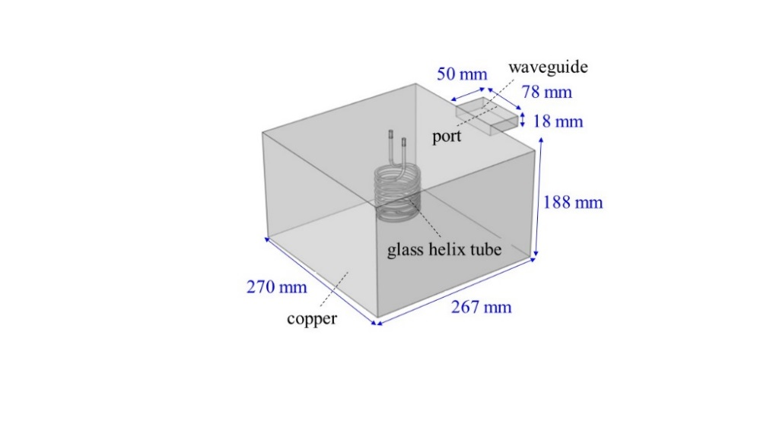 | 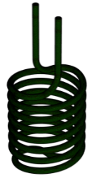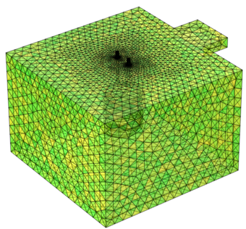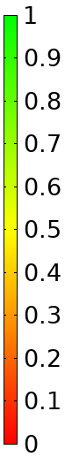  inlet  outlet
Fig. 1. Geometry model of kitchen MW oven and meshing including helical tube (tube length: 161.4 cm)

4. Results and discussion
The coupled electromagnetic, heat transfer and laminar flow model equations were solved for MW heating of water using the finite element method in COMSOL Multiphysics 5.5. The simulations were carried out on a computer with Intel Core i5-5300, 2.30 GHz processor, 8 GB RAM memory and 64-bit Windows 10 Enterprise operating system. The heat source computed in a stationary, frequency-domain electromagnetic analysis followed by a transient heat transfer and laminar flow simulation shows how the heat redistributes in the water associated with MW heating. The mesh independency was performed to find the optimum mesh quality and four scenarios with different element size were considered as illustrated in Table 1. The mesh element quality (MEQ) measures the morphological regularity of the mesh elements, which is important for model validation. The simulated water temperature at the outlet after 120 s MW heating is considered for grid-independent validation to assure reaching a thermal stability. A scenario in which the temperature error is less than 0.01% was selected. As the element number increases, the MEQ increases, while the temperature error decreases. The results will be reliable when the value of mesh quality is greater than 0.6 [26]. The considered meshes for water have very good quality and are accurate enough to obtain reliable results. There are 2225602 elements in the entire geometry with averaged element quality of 0.6705. The temperature simulation error of scenario #3 is small enough (0.008%) and it was selected instead of scenario #4 to decrease the computational time.

Table 1. Grid independent validation of the geometry model based on simulated temperature at the of the water outlet (central point) after 120 s MW heating (T_{in}: 20°C, P: 300W, Q: 0.8cm³/s, u: 4cm/s, τ: 39.5s, D: 5mm)
Scenario no. (i) | Element |  | Mesh element quality |  | T_{out} | $${\left(T_{i}-T_{calculate}\right)}/{T_{i}}$$
 | size | number | minimum | average | °C | %
1 | Coarser | 266977 | 0.1766 | 0.6550 | 68.790 | 0.084
2 | Normal | 653630 | 0.1104 | 0.6638 | 68.815 | 0.048
3 | Finer | 2225602 | 0.1057 | 0.6705 | 68.842 | 0.008
4 | Extremely Fine | 7719835 | 0.1148 | 0.6745 | 68.848 | -

4.1. Microwave power
It is obvious that larger power results in larger electric field intensity, which further contributes to higher MW heating effects within the same irradiation period. However, economic benefit should also be considered in industrial applications. The MW power effects were compared at the similar energy input of 6 kJ to the fluid under the frequency of 2.45 GHz, i.e., 100 W for 60 s to 500 W for 12 s. The simulation results are presented in Fig. 2. Higher input power results in a higher electric field intensity, which in turn causes a faster rise in temperature in the sample. The important feature of the MW heating, i.e. the volumetric heating effect, with the maximum temperature at the outlet be clearly observed from the simulation results. The rate of adsorbed energy for input power ranging from 100 to 500W was between 49.7 to 110 J/s, according to the simulated outlet temperature of water.

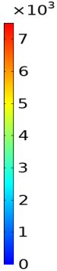 | 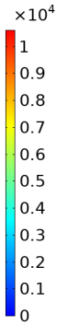 | 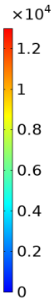 | 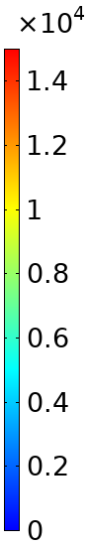 | 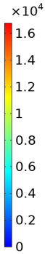
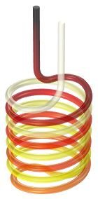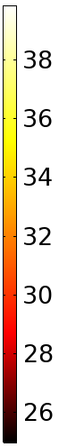 | 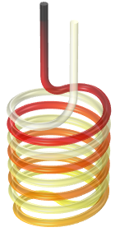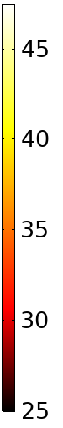 | 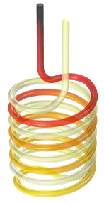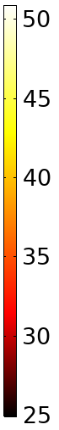 | 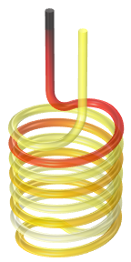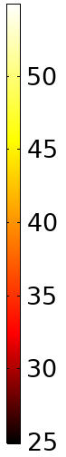 | 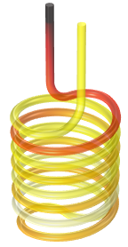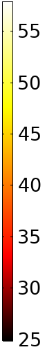
a) 100W after 60s | b) 200W after 30s | c) 300W after 20s | d) 400W after 15s | e) 500W after12s
Fig. 2. The thermal (°C) and electric (V/m) distributions of water under various input powers and similar energy input of 6 kJ (T_{in}: 20°C, Q: 0.8cm³/s, τ: 39.5s, D: 5mm).

The average temperaturee in helical tube and outlet temperature (maximum) were calculated (Fig.3). Although the minimum temperature remains constant, higher power led to a higher outlet temperature. It was found that larger input power contributes to more temperature difference between inlet and outlet liquid.

Fig. 3. Effect of power on temperature under similar energy input of 6 kJ
(T_{in}: 20°C, Q: 0.8cm³/s, τ: 39.5s, D: 5mm)

The relationship between the coefficient of variance of temperature (${COV}_{T}$) and the input power is illustrated in Fig. 4. As the MW power increases,${COV}_{T}$ increases; however, the difference in ${COV}_{T}$ between each consecutive power decreases. Two evolutionary modes depending on the MW power was observed. For the power range between 100 and 300 W, ${COV}_{T}$ increases with declining gradient and gradually reaches a stable value (steady state conditions). For powers more than $400 W$, ${COV}_{T}$ increases more sharply at the early stage of MW heating and then remain constant with prolonging heating time. The thermal evolutions indicate that power affects MW heating and temperature. This thermal heterogeneity along helical tube is a strong sign of increased COV_{T}. The higher input power resulted in a higher temperature difference along the tube.

Fig. 4. Effect of the MW power on the coefficient of variance of temperature
(T_{in}: 20°C, Q: 0.8cm³/s, τ: 39.5s, D: 5mm).

4.2. Liquid permittivity
Liquid permittivity has a determinant role in MW heating as it quantifies the amount of energy dissipated from the electromagnetic field. Dielectric properties are one of the important properties to assess the viability of heating effect due to the MWs and hence knowledge of the material dielectric properties is necessary. The ability of a dielectric material to absorb MWs and store energy is given by the complex permittivity$ε_{r}$ [28].The ratio of these two results in a parameter called the loss tangent, tan$δ={ε^{'}}/{ε^{''}}$. This parameter is used to describe the overall efficiency of a material to use energy sourced from the MW radiation [29].
According to Kappe [30], a reaction medium with high tan(δ) is required for a rapid heating. High microwave absorbing material normally has tan δ > 0.5, and low MW absorbing material has tan δ < 0.1. Medium MW absorbing material on the other hand, has tan δ in a range between 0.1 and 0.5 [29]. A higher loss tangent medium has a high interaction with the MW field, and the energy is transferred from the field to the medium. Therefore, a high loss tangent is related to a high dissipation factor. The greater the dissipation factor, the less the penetration of the MW energy into the material at the specific frequency [31]. The effect of the liquid permittivity on the electric and thermal field distributions is denoted in Fig.5, the other properties of liquid were considered as water (water based solutions of different permittivity including the loss factor: $ε^{''}$). The loss factor dominates the conversion of the electromagnetic energy into heat, however, it cannot influence the orientation of electric field. As the loss factor increases (Fig. 5), more electromagnetic energy is converted into heat to reduce the electric intensity and the outlet temperature increases.

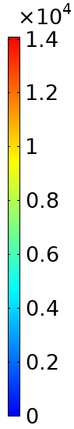 | 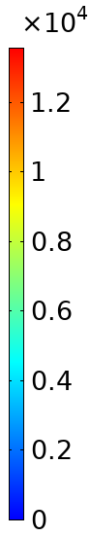 | 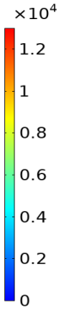 | 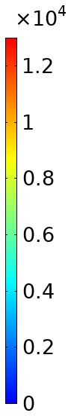 | 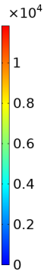
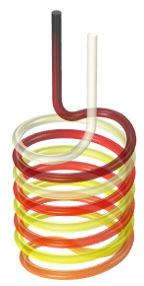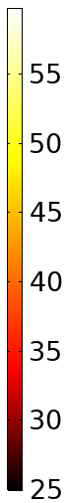 | 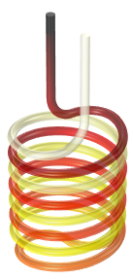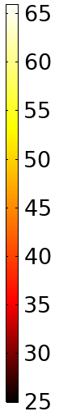 | 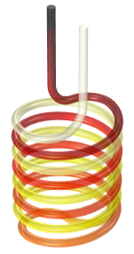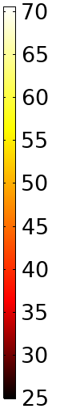 | 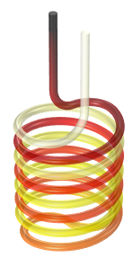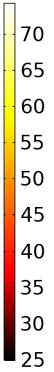 | 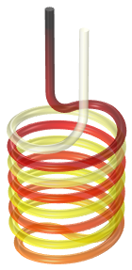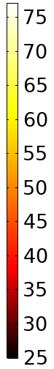
a) $ε^{''}:6$ | b) $ε^{''}: 8$ | c) $ε^{''}: 10$ | d) $ε^{''}: 12$ | e) $ε^{''}: 14$
Fig. 5. Effect of the liquid permittivity (loss factor) on the electric (V/m) and thermal (°C) field distributions after 120s MW heating ($ε^{'}: 78$, P: 300W, T_{in}: 20°C, Q: 0.8cm³/s, τ: 39.5s, D: 5mm)

The effect of the liquid permittivity on the energy efficiency, average temperature and ${COV}_{T}$ after120 s is presented in Fig. 6. As the loss factor increases, the efficiency, average temperature and ${COV}_{T}$ increase due to more conversion of electrical energy to heat. The complex permittivity parameter $ε_{r}$is both temperature and frequency dependent. The complex permittivity comprises a real and an imaginary part as shown in Eq. (3). The real part,$ε^{'}$ , represents the polarizability of a material and can be understood as the ability to store microwave energy. While the imaginary part, $ε^{''}$, represents the ability to transfer MW into heat. Therefore, materials with considerably different complex permittivity under MW irradiation own different temperature rise. The rate of adsorbed energy for loss factor ranging from 6 to 14 was between 116.8 to 174.7 J/s, according to the simulated outlet temperature of liquid.

Fig. 6. Effect of the liquid permittivity (loss factor) on the energy efficiency, the temperature and ${COV}_{T}$ after 120s (T_{in}: 20°C, Q: 0.8cm³/s, τ: 39.5s, D: 5mm)

4.3. Helical tube diameter
The configurations of the electric and temperature fields under different helix diameters for the similar residence time of liquid (τ: 39.5s) are provided in Fig. 7. The heating characteristic of the sample in the MW oven greatly depends on the diameter of the helical tube. Introduction of tubular reactor with different diameter destroys the regularity of the electric field throughout the oven and thus affects the electric and thermal distribution within the liquid. The electric field is not uniformly distributed inside the MW oven. The reflection of MW by the copper wall results in low and high energy zone in the electric field. With increasing diameter the regularity and intensity of the electric field is almost constant except when the diameter is 6 mm. Due to the depth of water penetration (33.4 mm) and with increasing the diameter, the intensity of the electric field in the center of the tube is becoming higher and the intensity in the walls decreases. Therefore, with increasing diameter from 6 mm, the outlet temperature decreases. A decrease in temperature is observed for tube of 5 mm in diameter due to the different distribution of the electric field under the constant residence time of fluid.

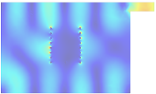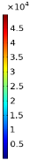 | 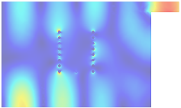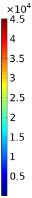 | 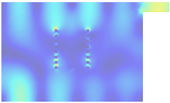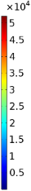 | 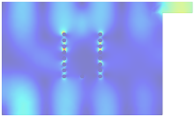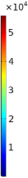 | 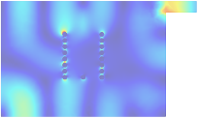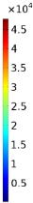
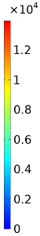 | 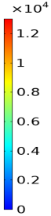 | 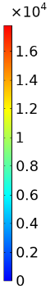 | 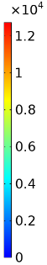 | 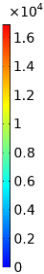
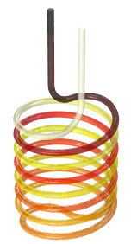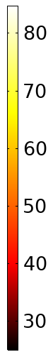 | 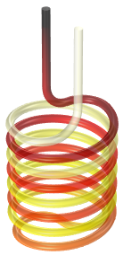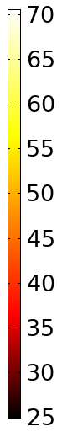 | 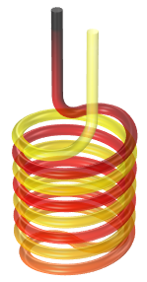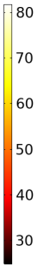 | 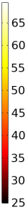 | 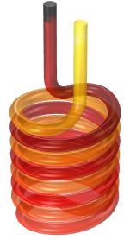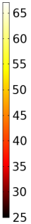
a) D: 4mm, Q: 0.5cm³/s  v*: 20.2cm³ | b) D: 5mm , Q: 0.8cm³/s  v: 31.6cm³ | c) D: 6mm, Q: 1.15cm³/s  v: 45.5cm³ | d) D: 7mm , Q: 1.57cm³/s  v: 62cm³ | e) D: 8mm, Q: 2cm³/s  v: 81cm³
*volume of helical tube
Fig. 7. Effect of diameter of helical tube on the electric field (V/m) in the ZOX plane, volume electric field (V/m) and temperature (°C) after 120s (P: 300W, T_{in}: 20°C, u: 4cm/s, τ: 39.5s, D: 5mm)

Quantitative results of the energy efficiency and the ${ COV}_{T}$ influenced by the diameter of helical tube as shown in Fig. 8. The efficiency increases with increasing diameter and reaches a peak value of approximately 84.6% when the tube diameter is 6 mm, indicating that 84.6% of the electromagnetic energy is converted to dielectric heat. The match between the irradiated helix and the oven size can significantly enhance the MW energy absorption efficiency. For the MW oven size used in the present work, the optimal diameter is 6 mm. The change tendency of ${ COV}_{T}$ is similar to that of the energy efficiency. As the diameter increases, the COV_{T} decreases slightly. This indicates that in a tube of larger diameter, the temperature is distributed more evenly. The effect of diameter on the outlet and average temperatures of the water is also shown in Fig. 8. As the diameter increases, outlet and average temperature decrease at a constant residence time of fluid. The highest temperature for tube diameter of 4 mm is more than 20% higher than that for tube diameter of 5 mm. The rate of adsorbed energy for tube diameter ranging from 4 to 8mm was between 157.5 to 373.8 J/s, according to the simulated outlet temperature of water.

Fig. 8. Effect of the helical tube diameter after 120s (P: 300W, T_{in}: 20°C, u: 4cm/s, τ: 39.5s)

5. Conclusions
A numerical study of the microwave heating is carried out and the effects of diameter of helical tube, input power and liquid permittivity were investigated by developing a comprehensive three-dimensional model coupling electromagnetic, heat transfer and laminar flow equations. Specified initial conditions and boundary conditions are given and a compilation of conclusions is given below.
- Increasing the power at lower irradiation period contributes to a greater thermal heterogeneity between outlet and inlet temperatures and a greater energy delivering. Low power requires thermal uniformity and energy savings, while high power is used for differential and fast heating.
- As the loss factor of liquid medium increases, more electromagnetic energy is converted to heat to reduce the electrical intensity. As a result, the outlet liquid temperature increases.
- The diameter of the helical tube affects the distribution of electric and thermal fields. There is an optimal helical diameter for water, as a liquid medium, in terms of efficiency. Due to the depth of penetration in water (33.4 mm), the intensity of the electric field in the center of the tube is the highest compared to the other points in a specified cross section. With increasing tube diameter at the constant residence time of fluid, the intensity of the electric field decreases near the walls, and the outlet temperature fluid decreases.

References
[1] Chan, C. H., Yusoff, R., Ngoh, G.C., 2014. Optimization of microwave-assisted extraction based on absorbed microwave power and energy. Chemical Engineering Science, 111, 41-47.‏
[2] Bhattacharya, M., Venkata, S.K., Basak, T., 2013. Role of microwave heating strategies in enhancing the progress of a first‐order endothermic reaction. AIChE Journal, 59(2), 656-670.‏
[3] Mimoso, R.M., Albuquerque, D.M., Pereira, J.M., Pereira, J.C., 2017. Simulation and control of continuous glass melting by microwave heating in a single-mode cavity with energy efficiency optimization. International Journal of Thermal Sciences, 111, 175-187.‏
[4] Sturm, G.S., Verweij, M.D., Van Gerven, T., Stankiewicz, A.I., Stefanidis, G.D., 2013. On the parametric sensitivity of heat generation by resonant microwave fields in process fluids. International Journal of Heat and Mass Transfer, 57(1), 375-388.‏
[5] Gawande, M.B., Shelke, S.N., Zboril, R., Varma, R.S., 2014. Microwave-assisted chemistry: synthetic applications for rapid assembly of nanomaterials and organics. Accounts of Chemical Research, 47(4), 1338-1348.
[6] Li, H., Cui, J., Liu, J., Li, X., Gao, X., 2017. Mechanism of the effects of microwave irradiation on the relative volatility of binary mixtures. AIChE Journal, 63(4), 1328-1337.‏
[7] Gao, X., Liu, X., Li, X., Zhang, J., Yang, Y., Li, H. (2018). Continuous microwave-assisted reactive distillation column: Pilot-scale experiments and model validation. Chemical Engineering Science, 186, 251-264.‏
[8] Gao, X., Li, X., Zhang, J., Sun, J., Li, H., 2013. Influence of a microwave irradiation field on vapor–liquid equilibrium. Chemical Engineering Science, 90, 213-220.‏
[9] Altman, E., Stefanidis, G.D., Van Gerven, T., Stankiewicz, A.I., 2010. Process intensification of reactive distillation for the synthesis of n-propyl propionate: the effects of microwave radiation on molecular separation and esterification reaction. Industrial & Engineering Chemistry Research, 49(21), 10287-10296.‏
[10] Ayappa, K.G., Brandon, S., Derby, J.J., Davis, H.T., Davis, E.A., 1994. Microwave driven convection in a square cavity. AIChE Journal, 40(7), 1268-1272.‏
[11] Finegan, T., Laibinis, P.E., Hatton, T.A., 2006. In‐situ measurements of temperature distributions in a microwave‐heated cavity. AIChE journal, 52(8), 2727-2735.‏
[12] Santos, T., Valente, M.A., Monteiro, J., Sousa, J., Costa, L.C., 2011. Electromagnetic and thermal history during microwave heating. Applied Thermal Engineering, 31(16), 3255-3261.‏
[13] Sturm, G.S., Verweij, M.D., Van Gerven, T., Stankiewicz, A.I., Stefanidis, G.D., 2012. On the effect of resonant microwave fields on temperature distribution in time and space. International Journal of Heat and Mass Transfer, 55(13-14), 3800-3811.‏
[14] Cha-um, W., Rattanadecho, P., Pakdee, W., 2011. Experimental and numerical analysis of microwave heating of water and oil using a rectangular wave guide: influence of sample sizes, positions, and microwave power. Food and Bioprocess Technology, 4(4), 544-558.‏
[15] Klinbun, W., Rattanadecho, P., 2012. Analysis of microwave induced natural convection in a single mode cavity (Influence of sample volume, placement, and microwave power level). Applied Mathematical Modelling, 36, 813-828.‏
[16] Li, H., Shi, S., Lin, B., Lu, J., Lu, Y., Ye, Q., Wang, Z., Hong, Y., Zhu, X., 2019. A fully coupled electromagnetic, heat transfer and multiphase porous media model for microwave heating of coal. Fuel Processing Technology, 189, 49-61.‏
[17] Buttress, A., Jones, A., Kingman, S., 2015. Microwave processing of cement and concrete materials-towards an industrial reality? Cement and Concrete Research, 68, 112-123.‏
[18] COMSOL Multiphysics, Heat transfer module user’s guide. version, 5.5,219.
[19] Mohammadi, M., Jovanovic, G.N., Sharp, K.V., 2013. Numerical study of flow uniformity and pressure characteristics within a microchannel array with triangular manifolds. Computers & Chemical Engineering, 52, 134-144.‏
[20] COMSOL Multiphysics, RF module user's guide. version 4.3b, Burlington, MA, USA, 2012.
[21] Gao, X., Liu, X., Yan, P., Li, X., Li, H., 2019. Numerical analysis and optimization of the microwave inductive heating performance of water film. International Journal of Heat and Mass Transfer, 139, 17-30.‏
[22] Microwave Oven, COMSOL Multiphysics application gallery, 2019.
[23] Huang, J., Xu, G., Hu, G., Kizil, M., Chen, Z., 2018. A coupled electromagnetic irradiation, heat and mass transfer model for microwave heating and its numerical simulation on coal. Fuel Processing Technology, 177,237-245.‏
[24] Chandrasekaran, S., Ramanathan, S., Basak, T. (2012). Microwave material processing-a review. AIChE Journal, 58(2), 330-363.‏
[25] Lin, B., Li, H., Chen, Z., Zheng, C., Hong, Y., Wang, Z., 2017. Sensitivity analysis on the microwave heating of coal: A coupled electromagnetic and heat transfer model. Applied Thermal Engineering, 126, 949-962.‏
[26] Lin, B.Q., Li, H., Dai, H.M., Zhu, C.J., Yao, H., 2016. Three-dimensional simulation of microwave heating coal sample with varying parameters. Applied Thermal Engineering, 93, 1145-1154.‏
[27] Microwave Oven, COMSOL Multiphysics Application Gallery, 2019.
[28] Chandrasekaran, S., Ramanathan, S., Basak, T., 2012. Microwave material processing-a review. AIChE Journal, 58(2), 330-363.‏
[29] Halim, S.A., Swithenbank, J., 2019. Simulation study of parameters influencing microwave heating of biomass. Journal of the Energy Institute, 92(4), 1191-1212.‏
[30] Kappe, C.O., 2004. Controlled microwave heating in modern organic synthesis. Angewandte Chemie International Edition, 43(46), 6250-6284.‏
[31] Tompsett, G.A., Conner, W.C., Yngvesson, K.S., 2006. Microwave synthesis of nanoporous materials. Chemphyschem: A European Journal of Chemical Physics and Physical Chemistry, 7(2), 296-319.‏

