A Low Noise Amplifier Design for 5G applications

Mohammad Mohammadi
University of Zanjan
Mhmd1375m@gmail.com

Abstract

This paper presents a 74GHz Low Noise Amplifier (LNA) for 5G applications. We used the gain-boosting technique to achieve a suitable gain. The simulation is between 73-76GHz and we chose the 74GHz as our operating frequency. The power consumption is about 5.7 mW from a 1.5V supply voltage. The achieved gain in the operating frequency is about 6.5 dB and the Noise Figure (NF) is below 5dB.

Keywords: Low Noise Amplifier, 5G applications, gain, NF.

Introduction
The communications commission (FCCs) ruling in February 2002 in the USA has approved the standard of ultra-wideband (UWB) technology to use a large bandwidth of 7.5 GHz from 3.1 GHz to 10.6 GHz for commercial applications. This standard provide low complexity, high data rate, low cost, low power dissipation and high security wireless telecommunication which can be used for short rang purposes. The most important reasons for quick growth in the designing of this circuits are request of these modules for medical imaging systems, wireless personal area networks, ground and vehicular penetrating radars, and sensor nodes for wireless networks. The CMOS technology is a suitable select for the implantation of low band UWB system when considering the hardware cost, time to market and the level of difficulty. The Low noise amplifiers is the first stage of a receiver. It must satisfy numerous specifications at the same time, which makes its design and implementation challenging [1]. As the LNAs is the first block in the receiving path and its noise figure(NF) is added to the overall noise figure of the receiver system; high gain and low noise are necessary for this module [2, 3]. In this paper we want to design and simulate an UWB Low Noise Amplifier with gain-boosting technique to increase the gain. Figure 1 Shows the gain boosting technique and its effect on the gain. In this technique we use an auxiliary amplifier that raises the equivalent g_{m} of M₂ by a factor of A₁+1, thereby boosting the output impedance of the stage. We surmise from Av= -G_{m}R_{out} that the voltage gain can be boosted. The short circuit transconductance in the circuit of Figure 1 is nearly equal to g_{m1}. So the gain would be equal to the below:

Av= g_{m1}[r_{o2}+(A₁+1)gm₂ro₂ro₁+ro₁] . (1)

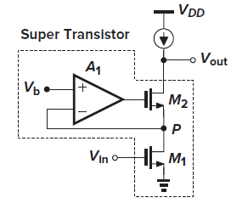
Fig 1. Basic gain-boosted stage .

Proposed circuit Design
As the first stage of receivers, LNAs plays a critical role in the overall performance. The noise figure of the LNA directly adds to that of a receiver. To gain a better feel for a noise figure, consider the Figure 2, where the noise of an LNA is represented by only a voltage source. Then we would have the equation below [4]:
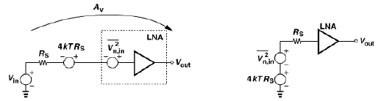
Fig 2. LNA with input-referred-noise voltage and its simplified circuit .
NF=V_{n,out}² / (4KTR_{s}.A_{v}²) (2)

= 1+ (V_{n,in}²/4KTR_{s}) (3)
The low noise required of LNAs limits the Choice of circuit topology. This often means that only one transistor-usually the input device- can be the dominant contributor to NF, thus ruling out the configuration such as emitter or source followers. The gain of the LNA must be large enough to minimize the noise contribution of subsequent stages. The choice of this gain leads to a compromise between the linearity and noise figure of a receiver as a high gain makes the nonlinearity of the subsequent stages more pronounced. In modern RF design, The LNA directly drives the down conversion mixers with no impedance matching between the two. Thus, It is meaningful and simpler to perform the chain calculations in terms of the voltage gain of the LNA. It is important to note that the noise and IP3 of the stage following the LNA are divided by different LNA gains. Figure 3 shows the LNA/mixer cascade, where the input-referred noise voltages are denoted by Vn,LNA2 and Vn,mixer2 and input noise currents are neglected. So The total output noise would be equal to:

NF_{tot}=NF_{LNA} + V_{n,mixer}²/(A_{v1}².4KTRs) (4)

In other words, for noise figure calculations, the noise of the second stage is divided by the gain from the input voltage source to the LNA output.

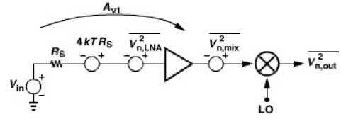
Fig 3. Appropriate choice of gain for referring noise.
The interface between antenna and the LNA entails an interesting issue that divides analog designers and microwave engineers. Considering the LNA as the voltage amplifier, we may expect that its input impedance must ideally be infinite. From the noise point of view, we may presented the LNA with a transformation network to obtain minimum noise figure. From the signal power point of view, we may realize conjugate matching between the LNA and the antenna[4]. The quality of the input match is expressed by the input return loss defined as the reflector power divided by the incident power. For a source impedance of Rs, the return loss is given by the equation below:

Γ=|(Z_{in}-R_{s})/(Z_{in}+R_{s})| (5)

Where Z_{in} denotes the input impedance. Unlike the other circuits in a receiver, the LNA must interface with the outside world, a poorly-controlled source impedance. For example, if a user of a cellphone wraps his/her hand around the antenna, the antenna impedance changes. For this reason, the LNA must remain stable for all source impedances at all frequencies. One may think that the LNA must operate properly only in the frequency band of the interest and not necessarily at other frequencies, but if the LNA begins to oscillate at any frequency, it becomes highly nonlinear and its gain is heavily compressed. A parameter often used to characterize the stability of the circuit is the Stern stability factor, defined as the equation below:

K=(1 + |Δ|² - |S₁₁|²- |S₂₂|²)/(2|S₂₁||S₁₂|) (6)

Where Δ=S₁₁S₂₂-S₁₂S₂₁. If K>1 and Δ<1, then the circuit is unconditionally stable, i.e, it does not oscillate with any combination of Source and Load impedances. In LNAs reducing power consumption and chip area while maintaining the same RF front-end devices in mobile communication standards. [5]. For various wireless standard, because of deficiency of spectrum source, the search on software defined radio and cognitive radio attract more attention. The complicated requirement on A/D converters makes it impractical. The receiver architecture constructed of LNA and down-conversion Mixer can avoid that problem and is widely accepted nowadays. Wideband LNAs considerably decrease area, cost, pins and power and can process several signal channels [6]. Nowadays, mobile phone technology advancement becomes more important due to the demands of users. Around 5 billion people are using mobile phones and 55% of connections are 3G/4G. Faster and reliable data connections for live video streaming becomes more important in the market. 3G and 4G operating bandwidth and spectrum are limited below 6GHz and occupied by many applications. 5G millimeter wave and beyond that (30-300GHz) networks are promising solution for user requirements [7]. The fifth generation of mobile communications is shaping out as a flexible infrastructure capable of handling the ever increasing demand for mobile data[8]. Ultra wideband (UWB) technology for 5G applications transmits binary data, using low energy and extremely short duration impulses over a very wide frequency band [9]. Figure 4 shows the proposed circuit design. The Simulated noise figure in the operating frequency is below 5dB. The gain of LNA must be large enough to minimize the noise contribution of subsequent stages. So the gain boosting technique will be a suitable method for increasing the gain to lower the noise figure. The gain that is achieved in the simulations is equal to 6.5 dB. The M2 and M8 transistors are cascoded. The transistor M12 is the gain-boosting transistor that can increase the gain at least 1000 times. The transistor M6 is the next stage loading that increases the gain and lowers the noise figure and it is suitable for 5G and beyond 5G applications. The dimensions of the transistors are: (W/L)4=(220nm/180nm), (W/L)8=(2um/0.18um), (W/L)14=(220nm/180nm) and (W/L)6=(16um/0.18um). the inductances in the input and output can improve the input and output matching. We have chosen the inductors L5, L10, L15 all equal to 1nH. And the capacitor equal to 1 pF. The all over gain of this amplifier in low frequencies is the equation below:

Av= g_{m8}[r_{o8}+(g_{m12}r_{o12} +1)g_{m4}ro₄ro₈+ro₄] (7)

And the input impedance of this amplifier would be equal to :

Z_{in}=R_{s}+ [jωL₁₅+ 1/(jωC_{in}) ] (8)
C_{in}= C_{gs8} (9)

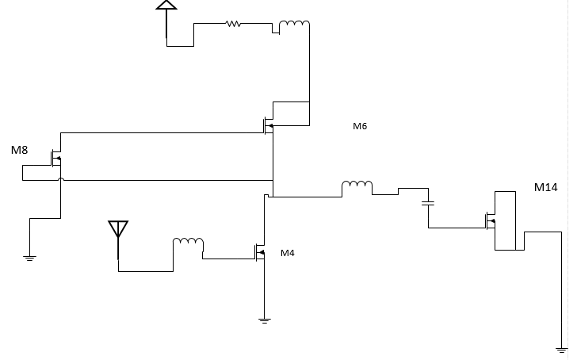

Fig 4. The proposed circuit design.

SIMULATION RESULTs
In this paper we designed and developed a low noise amplifier for beyond 5G applications in the frequency range of 73-76 GHz. The allover gain in this interval is between 2-8dB. But we chose the 74 GHz as the operating frequency. And in this frequency the gain is about 6.6dB and the noise figure is about 4.8 dB in this frequency. And it consumes a power of 8.6 mW from a 1.8 V supply voltage. Figure 5 shows the measured gain (S21) of this LNA that in the operating frequency is 6.5 dB and Figure 6 shows the noise figure of this proposed circuit that is 4.6dB.

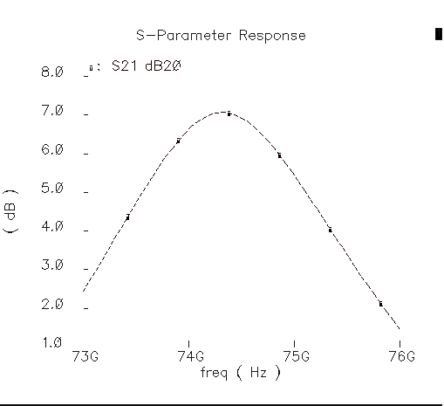
Fig 5. The simulated gain of the proposed LNA.

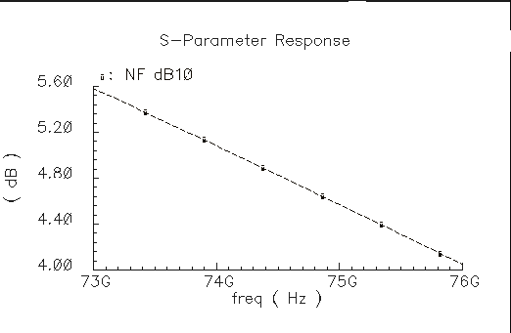
Fig 6. The simulated noise figure of the proposed LNA.

CONCLUSION
A 75 GHz LNA is designed and simulated in TSMC 180nm for beyond 5G applications. It has a power consumption equal to 5.7 mW that is lower than the other researches. The NF is about 4.6 dB that is almost equal to the other researches and the gain is about 6.8 dB. Because of the simplicity and low number of transistors it will consume a lower area and it will have a lower cost of fabrication.

Table 1. The comparison of this work with other researches.

Subject | [1] | [2] | [6] | [7] | [8] | [9] | This work
Technology | TSMC 180nm | TSMC 180nm | CMOS 130nm | TSMC 180nm | 90nm | 28nm LP | TSMC 180nm
NF(dB) | 3.4 | 2-5 | 1.1 | 2.9-3.3 | 3.92 | 4.9 | 4.6
Gain(S21) (dB) | 13.6 | >10 dB | 9.2 | 11 | 28 | 18.6 | 6.8
Power consumption (mW) | 17.5 | 10 | 6 | 7 | 18.37 | 27.6 | 5.7
Supply voltage(V) | 0.9 | 1.8 | 1.2 | 1.4 | 1.5 | 1.2 | 1.5
Frequency(GHz) | 3.1-10 | 3-7 | 1.5 | 2-8 | 56 | 33 | 74

References
[1] M. Yargholi and M.Babasafari, A Low Power CMOS UWB LNA with Dual-band Notch Filter Using Forward Body Biasing, IETE Journal of research, July 2018.
[2] M Yargholi, AP Tarighat, UWB resistive feedback LNA employing noise and distortion cancellation IEICE Electronics Express 9 (17), 1370-1377
[3] B. Razavi, Design of Analog CMOS Integrated circuits, 2nd edition, McGrawHill, 2017.
[4] B. Razavi, RF Microelectronics, 2nd edition, Prentice Hall, 2011.
[5] T. Leitner and etc. , A 1.2V,1.1-dB NF, CMOS Low-Noise Amplifier using an active-Tank Broadband output stage, conference paper, Feburary 2020.
[6] M. Yargholi and A.P. Tarighat, Low power active shunt feedback CMOS Low-Noise amplifier for wideband wireless systems, the VLSI Journal, 2019.
[7] A. Roobert and etc., Design of CMOS based LNA for 5G wireless applications.
[8] M. K. Hedayati and et al, A 33-GHz LNA for 5G Wireless systems in 28-nm Bulk CMOS, IEEE Transactions on circuits and systems-II: EXPRESS BRIEFES, VOL. 65, NO. 10., October 2018.
[9] M Yargholi, A highly linear squarer design for energy-detection RF receivers, Microelectronics Journal 44 (8), 658-662

