Design of a Mixer for 5G applications

Mohammad Mohammadi
University of Zanjan, Department of engineering, Faculty of electrical engineering
Mhmd1375m@gmail.com

Abstract

In this paper we are going to design an ultra wideband mixer for 5G applications. In this paper we have designed a 5G mixer that it has a noise figure (NF) between 9- 15dB and a gain of 20 dB in the operating frequency of 29 GHz. In this paper the proposed mixer is designed in TSMC 180nm. has a reversed Isolation of -10 dB in this frequency and it has a OP1dB of 25 dBm in the RF port of 20dBm. The IP3 of the proposed mixer is about 50dBm. The techniques that we have used for designing the proposed mixer is the current mirror PMOS transistors with inductive degeneration in current mirror transistors to increase the gain and improve linearity .and inductive source degeneration technique is used to improve the IP3.

Keywords: UWB mixer, 5G applications, Noise Figure, Gain.

Introduction
Wireless communications is, by any measure the fastest growing segments of communications industry. As such it has captured the attention of media and the imagination of the public. Cellular systems have experienced exponential growth in the last decades[1]. A common approach to transmitting amplitude and phase modulated signals, especially at very high frequencies, is to back-off from the OP1dB of transmitter by a sufficient margin[2]. Digital radio frequency RF transmitters have gained popularity in recent years. The realization of transmit functions in the digital domain offers many advantages[3]. In recent years, new generation wireless communications standard such as 5G cellular standard is being developed to provide Gb/s data transfer in the wireless data traffic. As broadband spectrum can be used to support Gb/s data transfers, many countries such as the US, EU, Korea, China, and Japan have planned to use the millimeter band for 5G communication services[4]. Development of 5G wireless communication requires high data rates, wide signal bandwidth, good signal to noise ratios(SNR) and efficient systems has pushed the telecommunication industry to strive beyond operating frequencies such as under 6GHz, as has been the norm in older communication standards. Millimeter wave frequencies ranging from around 10 GHz up to several hundreds of GHz, contain spectral resources that are still infrequently used, and could provide a platform in expected growth in wireless communications in the future [5]. Mixers are of integral parts of radio systems. Due to large-signal input, this block is usually quite nonlinear. This three-port block is used in receivers to down convert the RF signal and in transmitters to up convert the modulated signal. Due to their intrinsic nonlinear behavior and port to port leakage, this blocks mandate specific analysis for their operation. Moreover, taking into account their ever existing harmonics in transceivers, it is necessary to achieve a high performance system. In normal mixer operation, there is a large signal which is the local oscillator and two other small signals which are the RF and IF signals. Upon driving a mixer's input toward large signal regime (either of IF or RF signals) depending on the fact that the mixer is up converter or down converter, the output cam pass through saturation[6]. The overall system linearity is defined by a mixer. Passive and active mixers are two important types of mixers. The passive mixer has high linearity, but it does not present a gain and it suffers from from higher conversion loss and noise figure. The active mixer contains single balanced and double balanced Gilbert cell mixer. The traditional double balanced Gilbert mixer is chosen for investigation because it has good LO to RF and LO to IF port. Isolation makes the DC offset problem less which is easily filtered out at the output. Fig. 1 shows a the CMOS Gilbert cell mixer, including trans conductance stage, switch stages and load network. The double balanced Gilbert mixer has high linearity than single balanced switching Mixer. To attain good linearity, high conversion gain and low noise figure, transistors M1-M6 are designed in saturation region. The switch stages are driver by a local oscillation signal. The LO signal must be large to make M3-M6 act as switches[7].

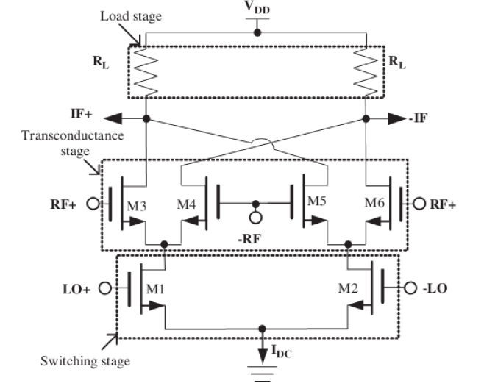
Fig 1. CMOS Gilbert Cell Mixer .

Proposed Mixer Design
The proposed mixer is designed and simulated based on Gilbert cell. There are several mechanism at the orgin of intermodulation in CNOS down conversion Mixers: self mixing, trans conductor nonlinearity and mismatch in load resistors . Figure 2 shows the proposed down-conversion mixer. The expression for total noise output is expressed in terms of bias quantities by replacing gm for a short channel MOSFET by I/ (V_{GS}-V_{th}), then we would have:

(1)  (2) | V_{o,n}²= 8kTR_{L}(1+ γR_{L}I/[2(V_{GS}-V_{th})]+ γR_{L}I/[πA] )  NF= 1+(V_{o,n}²/4KTRsA²)
This shows that the relative noise contribution of the switches to the trans conductance FET is 2(V_{GS}-V_{th})/ πA. As the gate over-drive bias on the trans conductance FET approaches the sine-wave LO amplitude, the switches, and trans conductance stage contribute comparable noise at the mixer output. This is the fundamental trade-off between noise and linearity in active mixers. Linear mixers may bias the trans conductance FET at a Large over-drive to enhance the linearity, accompanied by the modest LO swing to keep the switch transistors operating in saturation [8]. The derived Noise Figure in the proposed Mixer is about 9dB at the operating frequency of 29 GHz. Figure 3. Shows the NF of the proposed down- conversion Mixer.
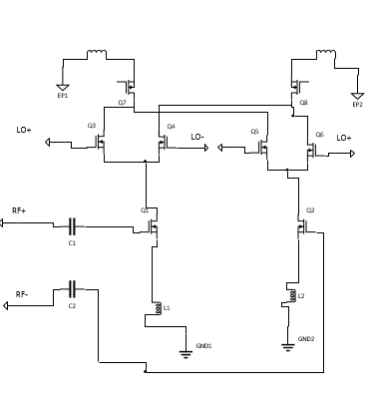
Fig 2. Proposed down-conversion Mixer.

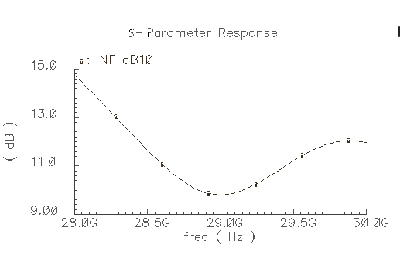
Fig 3. The NF of proposed down-conversion Mixer.

The proposed down-conversion Mixer has PMOS transistors that works as current mirrors to increase the gain and inductive source degeneration technique that enhances the linearity of IF and RF ports. The small signal gain of a circuit is usually obtained with the assumption that harmonics are negligible. However our formulation of harmonics is equal to α₁+3α₃A²/4 and hence varies appreciably as A becomes larger. The OP1dB is as the equation below[9]:

20Log| α₁+3α₃A²/4 |= 20Log| α₁ | -1 dB (1)

A_{in,1dB}= (0.145| α₁/α₃|)^{0.5} (2)

And the third order intermodulation is equal to the equation below:

IIP3= (| 4α₁/(3α₃)|)^{0.5} (3)

The small signal gain of the proposed down conversion Mixer at very low frequencies would be equal to:

A= (2/π) g_{m}r_{o} (4)

The degeneration inductors of L1 and L2 are 50 pF which reduces the consumption area and the quality factor of inductors will increase and hence the gain. as the gain increases the NF decreases. And we used LO gate capacitors ( C1 and C2) to improve the gain and the impedance matching. Their value are equal to 1 pF. The inductors L3 and L4 are used to improve the linearity and reverse isolation that they are 40dBm and -10 dB, respectively. And the dimentions of the transistors( M1-M2) are (1um/ 0.18um). The dimentions of the (M3-M6) are equal to (500nm/180nm) and the PMOS devices( M7-M8) are (0.22um/0.18um).

Simulation results
The simulation results show that the gain in the operating frequency of 29GHz is 20 dB (Fig. 4) and the op1dB is equal to 25 dBm (Fig 5) and the IIP3 is equal to 40dBm( Fig. 6). And the reverse isolation is -10 dB. The power consumption from a 1.8V supply voltage is 0.9mW.

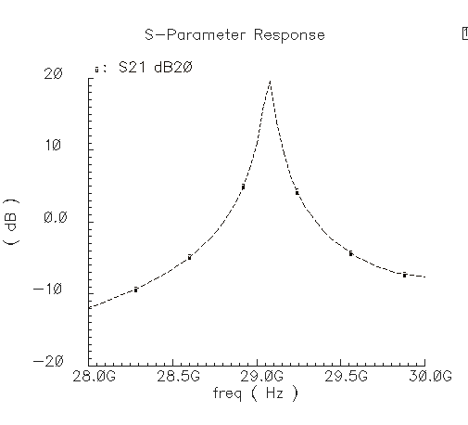
Fig 5. The gain of the proposed down- conversion mixer.

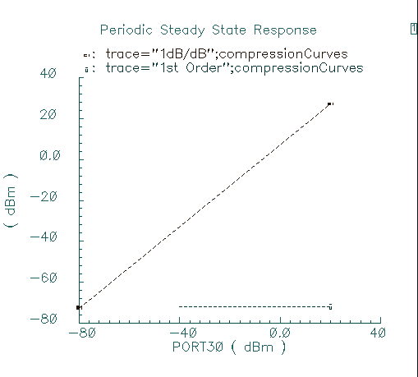
Fig 6. OP1dB of the proposed down-conversion Mixer.

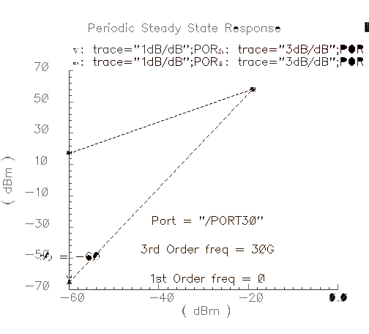
Fig 7. IIp3 of the proposed down-conversion Mixer.

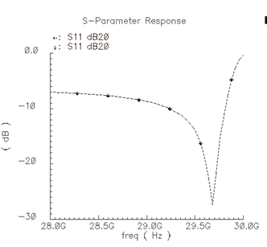
Fig 8. Reverse Isolation of Proposed down-conversion Mixer.

Conclusion
In this paper we designed a 29 GHz down-conversion Mixer for 5G applications. The gain is more than the investigated researches and hence the noise figure is less. We have fewer power consumption. So typically this proposed down-conversion Mixer is better than the previous ones that is investigated here.

Table 1. Comparsion between this research and other researches.
Parameters/References | [4] | [5] | [7] | This work
Operating Frequency (GHz) | 26.5-29.5 | 20-80 | 8-10 | 29
Gain(dB) | 10.1 | 5< | 11 | 20
OIP3(dBm) | 19.3 | 4.9 | 12 | 40
NF(dB) | 9.9 | 5.1 | 14-20 | 9
Power consumption(mW) | 11 | N/A | 1.9 | 0.9
OP1dB(dBm) | -7 | N/A | 0 | 25
S11(dB) | N/A | -20 | N/A | -10
Supply voltage | 1 V | 1.8v | 1.2 | 1.8
Technology | 65 nm  CMOS | 22nm  FDSOI | 0.18 um | 0.18 um

References

[1] A. Goldsmith, wireless communications, Cambridge university press, 2005.

[2] C. K. Liang and B.Razavi, Transmitter linearization by beam forming, IEEE JOURNAL of solid state circuits, VOL. 46, NO. 9, SEPTEMBER 2011.

[3] M. Babamir and B. Razavi, A Digital RF transmitter with Background Nonlinearity corrections, IEEE journal of solid state circuits, 2020.

[4] C. Kim, M. Kim, Y. Jeon, O. Lee, J. H. Son, I. Nam, A 28-GHz CMOS Down conversion Mixer with Low-magnetic-coupled Source degeneration inductors for 5G applications, Journal of Semiconductor technology and science, VOL.19, NO. 4, August 2019.

[5] H. Hurskainen, Design of a 20-80 GHz Down-conversion Mixer for 5G Wireless communication with 22nm CMOS, 2nd 6G Wireless summit, 2020.

[6] A. Fotowat, F. Farzaneh, M. Kamarei, A. Nikoofard, M. Elmi, Introduction to wireless communication circuits, River publisher, 2018.

[7] M. Yargholi, F. Darvishi, A Low voltage high- Linearity UWB down-conversion Mixer in 0.18 um CMOS Technology, The 22nd Iranian Conference on electrical engineering, May 20-22, 2014.

[8] H. Darabi, A. Abidi, Noise in RF-CMOS Mixers: A Simple Physical model, IEEE TRANSACTIONS ON SOLID STATE CIRCUITS, VOL. 35, NO. 1, January 2000.

[9] B. Razavi, RF Microelectronics, 2nd edition, PRENTICE HALL, 2012.

